

City of Doncaster Council

Air Quality Action Plan
In fulfilment of Part IV of the Environment Act 1995
Local Air Quality Management
30th June (2023)

Information | City of Doncaster Council Details
Local Authority Officer | Mathew Julian
Department | Regulation and Enforcement
Address | Civic Office, Waterdale, Doncaster, DN1 3BU.
Telephone | 01302 862601
E-mail | Matthew.julian@doncaster.gov.uk
Report Reference Number | AQAP2023
Date | June 2023

Executive Summary
This Air Quality Action Plan (AQAP) has been produced as part of our statutory duties required by the Local Air Quality Management framework. It outlines the action we will take to improve air quality in Doncaster between 2024 and 2027.
This action plan replaces the previous action plan which ran from June 2018 to June 2023. Projects delivered through the past action plan include:

- Fuelling Change Campaign - Through-out 2018 the Fuelling Change Campaign, funded via the Air Quality Grant, delivered events and website resources (www.fuellingchange.co.uk) to the residents of Doncaster and the wider South Yorkshire area. The scheme was a success and has now concluded.
- ECO Stars – ECO Stars was a Fleet Recognition Scheme that aimed to help fleet operators improve efficiency, reduce fuel consumption and emissions. A lack of funding has led to the cessation of the scheme and the removal of this measure.
- Air Quality and Planning Technical Guidance – This measure is currently in use on 100% of applications that Pollution Control are consulted on. A Supplementary Planning Document has now been published and includes the Air Quality Technical Guidance
- Clean Air Feasibility Study - Ricardo Energy and Environment were commissioned to conduct a vehicle emission study and subsequent modelling exercise for Air Quality Management Area 7 (AQMA). These reports have been completed and are available on the Council’s website. Findings from these Ricardo reports have been considered and utilised when formulating the measures to address the exceedances in AQMA 7.
- Investigate the feasibility of green barriers in Doncaster’s Air Quality Management Areas (AQMAs) – initial assessment considered there to be insufficient available space to implement this in AQMAs 2 and 7 which are the only AQMAs in Doncaster that are currently in exceedance.
- Highways Planned Maintenance Scheme Priority - Enhanced software is now in place. Work is currently on going to further develop the communication plan for the dissemination of road works and incidents on the highway network which result in disruption. All road works on the network can now be accessed by the public graphically via the web using One.Network. This system has been added to the Councils website via a web-based portal to integrate the system. The system also shows congestion/delays on the network via a Red-Amber-Green (RAG) rating approach to assist with journey planning.
- 20mph Speed Limits – Over 60% of appropriate residential streets across the borough now have a 20 mph speed limit, with the programme being further accelerated over the next two years. Modelling of the impact associated with this measure on AQMA7, has also been undertaken.

Air pollution is associated with a number of adverse health impacts. It is recognised as a contributing factor in the onset of heart disease and cancer. Additionally, air pollution particularly affects the most vulnerable in society: children and older people, and those with heart and lung conditions. There is also often a strong correlation with equalities issues, because areas with poor air quality are also often the less affluent areas,.
The annual health cost to society of the impacts of particulate matter alone in the UK is estimated to be around £16 billion. City of Doncaster Council is committed to reducing the exposure of people in Doncaster to poor air quality in order to improve health.
We have developed actions that can be considered under six broad topics:
- Promoting low emission transport
- Promoting travel alternatives
- Alternatives to private vehicle use
- Vehicle fleet efficiency
- Transport planning and infrastructure
- Public Information

Our priorities are to gain an increased understanding of the concentrations and sources impacting AQMA 2 while focussing on and investigating innovative and impactful measures to address the exceedance of air quality objectives in AQMA 7. We will continue to encourage a modal shift towards Active Travel and low/zero emission vehicles.
In this AQAP we outline how we plan to effectively tackle air quality issues within our control. However, we recognise that there are a large number of air quality policy areas that are outside of our influence (such as vehicle emissions standards agreed in Europe), but for which we may have useful evidence, and so we will continue to work with regional and central government on policies and issues beyond the City of Doncaster Council’s direct influence.

Responsibilities and Commitment
This AQAP was prepared by the Regulation and Enforcement Department of City of Doncaster Council with the support and agreement of the following officers and departments:
Mathew Julian Senior Pollution Control Officer
Ian Kellett Senior Pollution Control Officer
Scott Forbes Environmental Protection Manager
Lisa Croft Senior Policy, Insight and Change Manager
Caroline Temperton Public Health Lead Wider Determinants
Dave Haig Safer Roads Manager
Neil Firth Head of Service Major Projects and Investment
Claire Bignell Head of Service Regulation and Enforcement
Emma Wilson Public Health Improvement Coordinator
Kerry Needham Public Health Project Officer
Roy Sykes Head of Planning
David Snell Head of Service - Highways Infrastructure
John Davies Enforcement Manager
Richard James Smith Head of Sustainability
Kellie Hopkins Service Director (Place)
Dan Swaine Executive Director (Place)
Rupert Suckling Director of Public Health

This AQAP has been approved by:
Public Health
Transportation Unit
Highways
Transport and Production
Regulation & Enforcement

This AQAP will be signed off by Councillor Mark Houlbrook portfolio holder for Sustainability and Waste.
This AQAP will be subject to an annual review, appraisal of progress and reporting to relevant Council Officers and Committees as required Progress each year will be reported in the Annual Status Reports (ASRs) produced by City of Doncaster Council, as part of our statutory Local Air Quality Management duties.
If you have any comments on this AQAP please send them to Mathew Julian at:
City of Doncaster Council, Civic Building, Waterdale, Doncaster, DN1 3BU.
(01302) 862601
Matthew.julian@doncaster.gov.uk
Pollution.Control@doncaster.gov.uk
Table of Contents
Executive Summary i
Responsibilities and Commitment iii
1. Introduction 1
2. Summary of Current Air Quality in Doncaster 3
Figure 2.1 AQMA 1 City Centre along A630 Church Way 4
Figure 2.2 AQMA 2 Balby Road A630 with diffusion tube locations 4
Figure 2.3 AQMA 3 Carr House Road A18 with diffusion tube locations 5
Figure 2.4 AQMA 4 Bawtry Road M18/A638, Bessacarr with diffusion tube locations 5
Figure 2.5 AQMA 5 Low Road A630, Conisbrough with diffusion tube locations 6
Figure 2.6 AQMA 6 Skellow A1 with diffusion tube locations 6
Figure 2.7 AQMA 7 Hickleton A635 with diffusion tube locations 7
Figure 2.8 AQMA 7A Marr A635 with diffusion tube locations 7
Table 2.1 - AQMA 1, A630 Church Way 8
Table 2.2 - AQMA 2, A630 Balby Road 9
Table 2.3 - AQMA 3, A18 Carr House Road 9
Table 2.4 - AQMA 4, M18/A638 Bawtry Road, Bessacarr 9
Table 2.5 - AQMA 5, A630/Low Road, Conisbrough 9
Table 2.6 - AQMA 6, A1 Skellow 9
Table 2.7 - AQMA7, A635 Hickleton 10
Table 2.8 - AQMA 7A, A635 Marr 10
Figure 2.9 Annual Mean NO2 Concentration (µg/m3), AQMA 1 11
Figure 2.10 Annual Mean NO2 Concentration (µg/m3), AQMA 2 12
Figure 2.11 Annual Mean NO2 Concentration (µg/m3), AQMA 3 13
Figure 2.12 Annual Mean NO2 Concentration (µg/m3), AQMA 4 14
Figure 2.13 Annual Mean NO2 Concentration (µg/m3), AQMA 5 15
Figure 2.14 Annual Mean NO2 Concentration (µg/m3), AQMA 6 16
Figure 2.15 Annual Mean NO2 Concentration (µg/m3), AQMA 7 17
Figure 2.16 Annual Mean NO2 Concentration (µg/m3), AQMA 7A 18
3. City of Doncaster Council’s Air Quality Priorities 19
Figure 3.1 AQMA 1 Road NOx Source Apportionment 26
Figure 3.2 AQMA 2 Road NOx Source Apportionment 26
Figure 3.3 AQMA 3 Road NOx Source Apportionment 27
Figure 3.4 AQMA 4 Road NOx Source Apportionment 27
Figure 3.5 AQMA 5 Road NOx Source Apportionment 28
Figure 3.6 AQMA 6 Road NOx Source Apportionment 29
Figure 3.7 AQMA 7 Road NOx Source Apportionment 29
Figure 3.8 AQMA 7A Road NOx Source Apportionment 30
Figure 3.9 Source Apportionment of NO₂ concentrations in AQMA 1 33
Figure 3.10 Source Apportionment of NO₂ concentrations in AQMA 2 33
Figure 3.11 Source Apportionment of NO₂ concentrations in AQMA 3 34
Figure 3.12 Source Apportionment of NO₂ concentrations in AQMA 4 34
Figure 3.13 Source Apportionment of NO₂ concentrations in AQMA 5 35
Figure 3.14 Source Apportionment of NO₂ concentrations in AQMA 6 35
Figure 3.15 Source Apportionment of NO₂ concentrations in AQMA 7 36
Figure 3.16 Source Apportionment of NO₂ concentrations in AQMA 7A 36
Table 3.1 Emission Reductions Required to Achieve Compliance with the Air Quality Objectives in (µg/m3) 37
Table 3.2 Road NOx Emission Reductions Required to Achieve Compliance with the Air Quality Objectives (%) 38
4. Development and Implementation of City of Doncaster Council AQAP 40
Table 4.1 ‒ Consultation Undertaken 40
5. AQAP Measures 42
Table 5.1 ‒ Air Quality Action Plan Measures 46
Appendix A: Response to Consultation 49
Appendix B: Reasons for Not Pursuing Action Plan Measures 50
Appendix C: Steering Group Terms of Reference 56
Appendix D: Previous Action Plan measures 59
Appendix E: Air Quality situation in AQMA 7, Hickleton 64
Glossary of Terms 81
References 83

1. Introduction
This report outlines the actions that City of Doncaster Council will deliver between 2024 – 2027 in order to reduce concentrations of air pollutants and exposure to air pollution; thereby positively impacting on the health and quality of life of residents and visitors to the City of Doncaster.
It has been developed in recognition of the legal requirement on the local authority to work towards Air Quality Strategy (AQS) objectives under Part IV of the Environment Act 1995 and relevant regulations made under that part and to meet the requirements of the Local Air Quality Management (LAQM) statutory process.
This Plan will be reviewed every five years at the latest and progress on measures set out within this Plan will be reported on annually within City of Doncaster Council’s air quality Annual Status Report (ASR).
This action plan replaces the previous action plan which dates ran from June 2018 till June 2023. Projects delivered through the previous action plan include:
- Fuelling Change Campaign
- ECO Stars
- Air Quality and Planning Technical Guidance
- Clean Air Feasibility Study
- Investigate the feasibility of green barriers in Doncaster’s AQMAs
- Highways Planned Maintenance Scheme Priority
- 20mph Speed Limits

Ongoing measures include
- Cycling Strategy
- Walking Strategy
- Quality Bus Partnership
- Future (Fleet) Transport Policy

A total of ten measures have been identified representing a package of measures to achieve compliance in our Air quality Management Areas (AQMAs).
To better identify measures likely to be sufficient to address the significant exceedance of the Air Quality Standards, a vehicle emission monitoring study and a subsequent modelling exercise have been completed by Ricardo Energy and Environment in relation to AQMA 7.

2. Summary of Current Air Quality in Doncaster
Location and context
In Doncaster there are a number of locations where concentrations for the pollutant nitrogen dioxide is above the recommended objective. These objectives are set with regard to the impact nitrogen dioxide has on the health of the public.
These locations have been declared as Air Quality Management Areas (AQMAs) some of which have been in place since 2001. There is a total of eight AQMAs across Doncaster. As with much of the UK these localised areas are the result of local road transport and while improvements were expected over time due to cleaner vehicle technologies, exceedances of the national objectives have still been identified in the existing AQMAs.
The AQMAs are located near busy roads in the following areas: AQMA 1 - City Centre along A630 Church Way; AQMA 2 - Balby A630; AQMA 3 - Hyde Park along Carr House Road A18; AQMA 4 - Bawtry Road M18/A638; AQMA 5 - Conisbrough A630/Low Road; AQMA 6 - Skellow, adjacent to the A1, with AQMA 7- Hickleton and AQMA 7A - Marr on the A635. The location of the AQMAs are shown below.

Figure 2.1 AQMA 1 City Centre along A630 Church Way
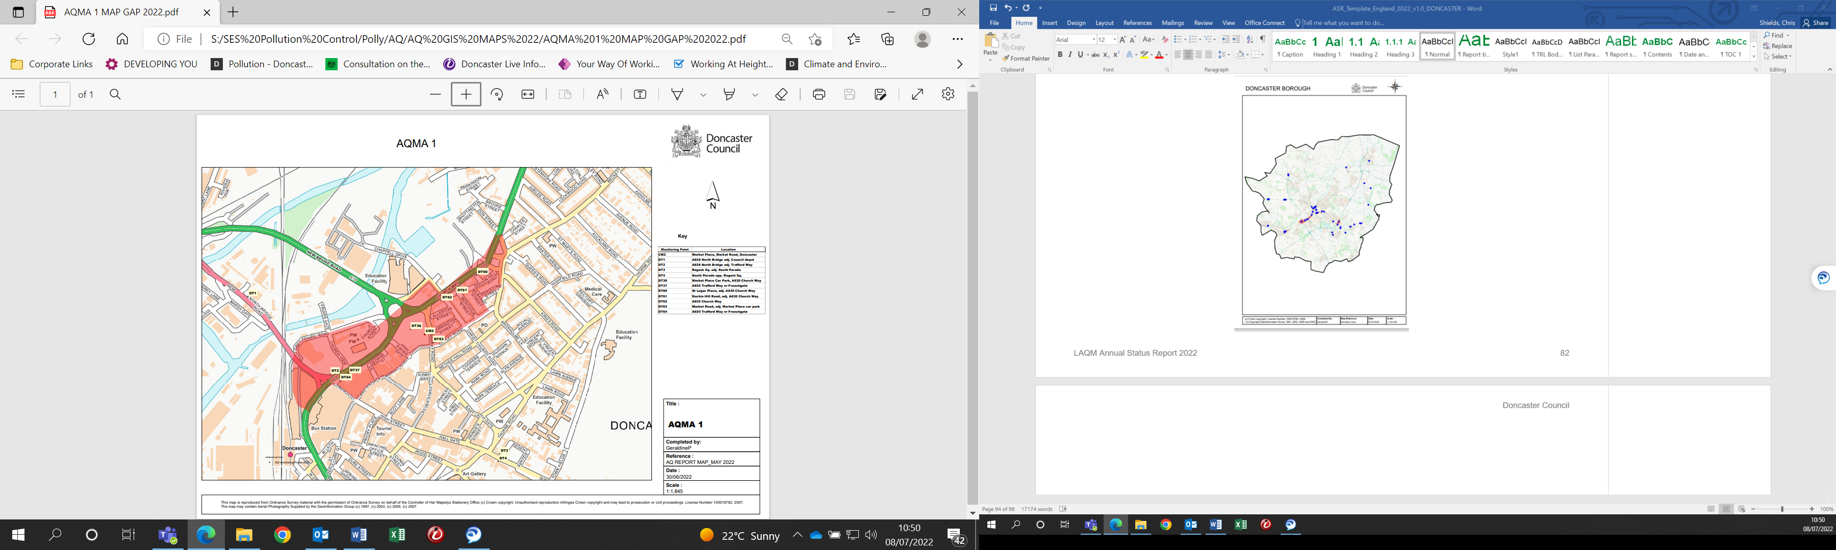

Figure 2.2 AQMA 2 Balby Road A630 with diffusion tube locations
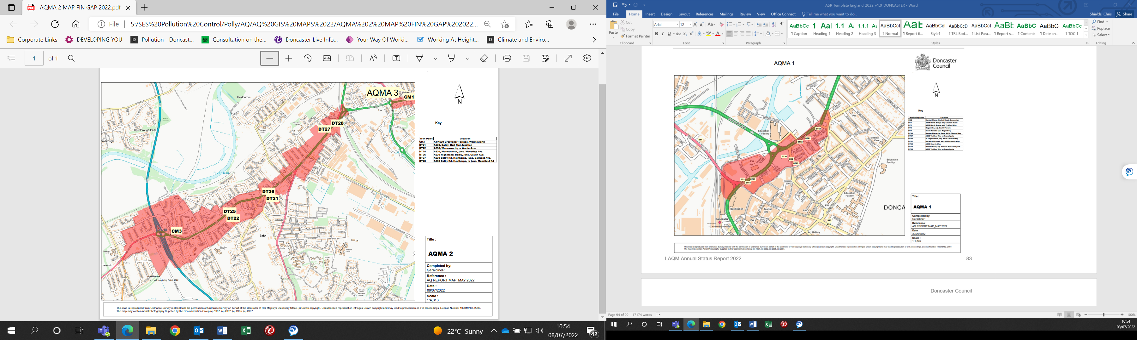

Figure 2.3 AQMA 3 Carr House Road A18 with diffusion tube locations
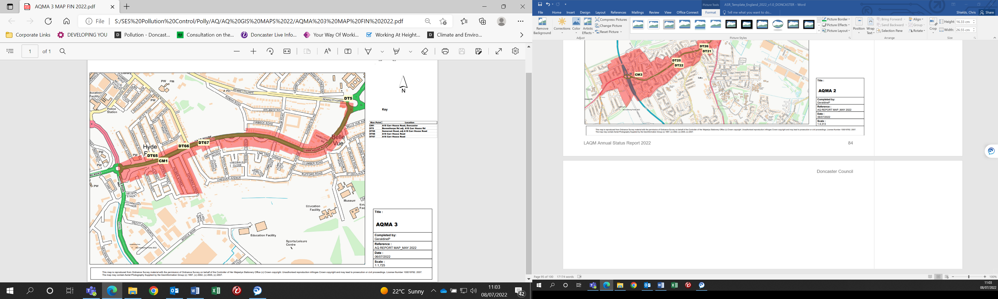

Figure 2.4 AQMA 4 Bawtry Road M18/A638, Bessacarr with diffusion tube locations
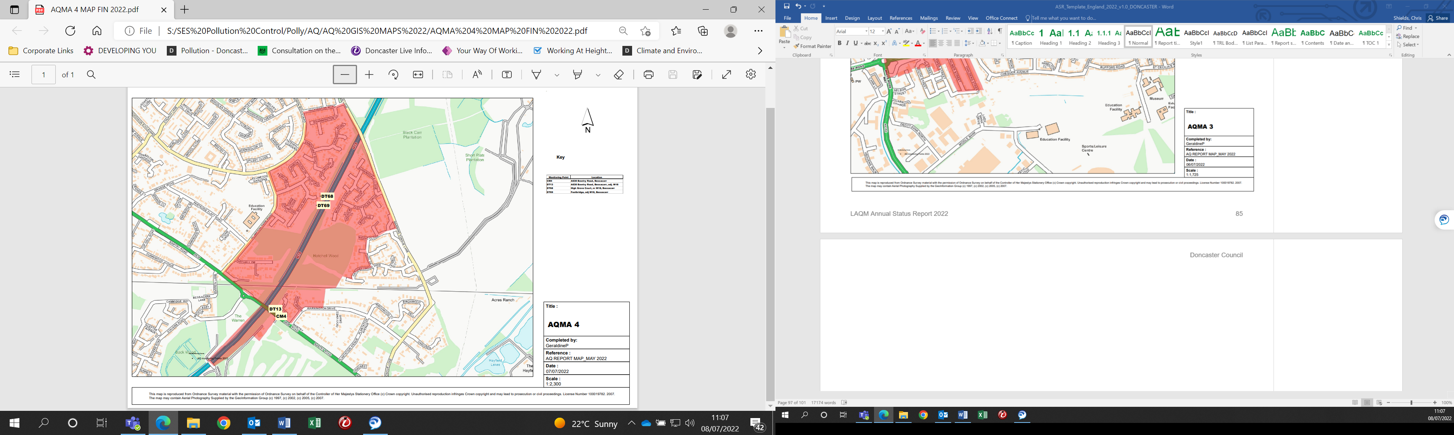

Figure 2.5 AQMA 5 Low Road A630, Conisbrough with diffusion tube locations
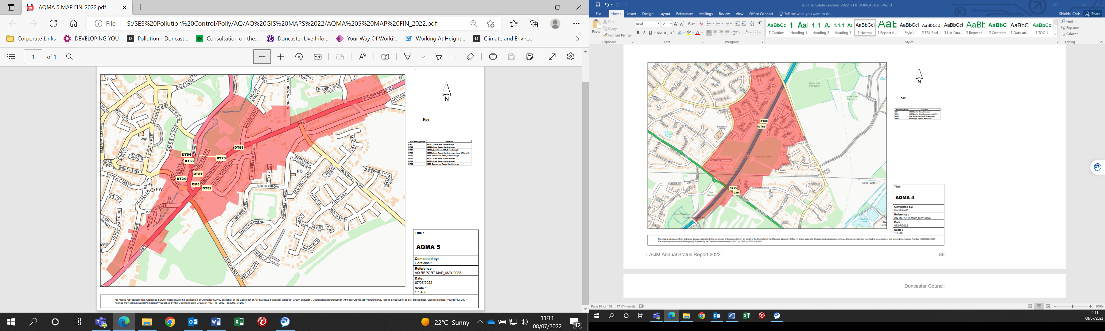

Figure 2.6 AQMA 6 Skellow A1 with diffusion tube locations
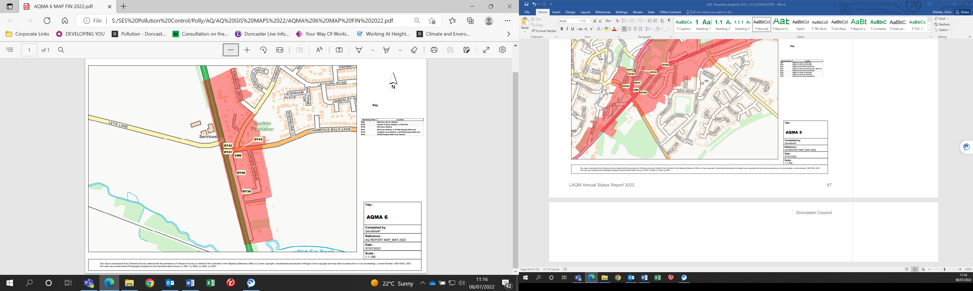

Figure 2.7 AQMA 7 Hickleton A635 with diffusion tube locations
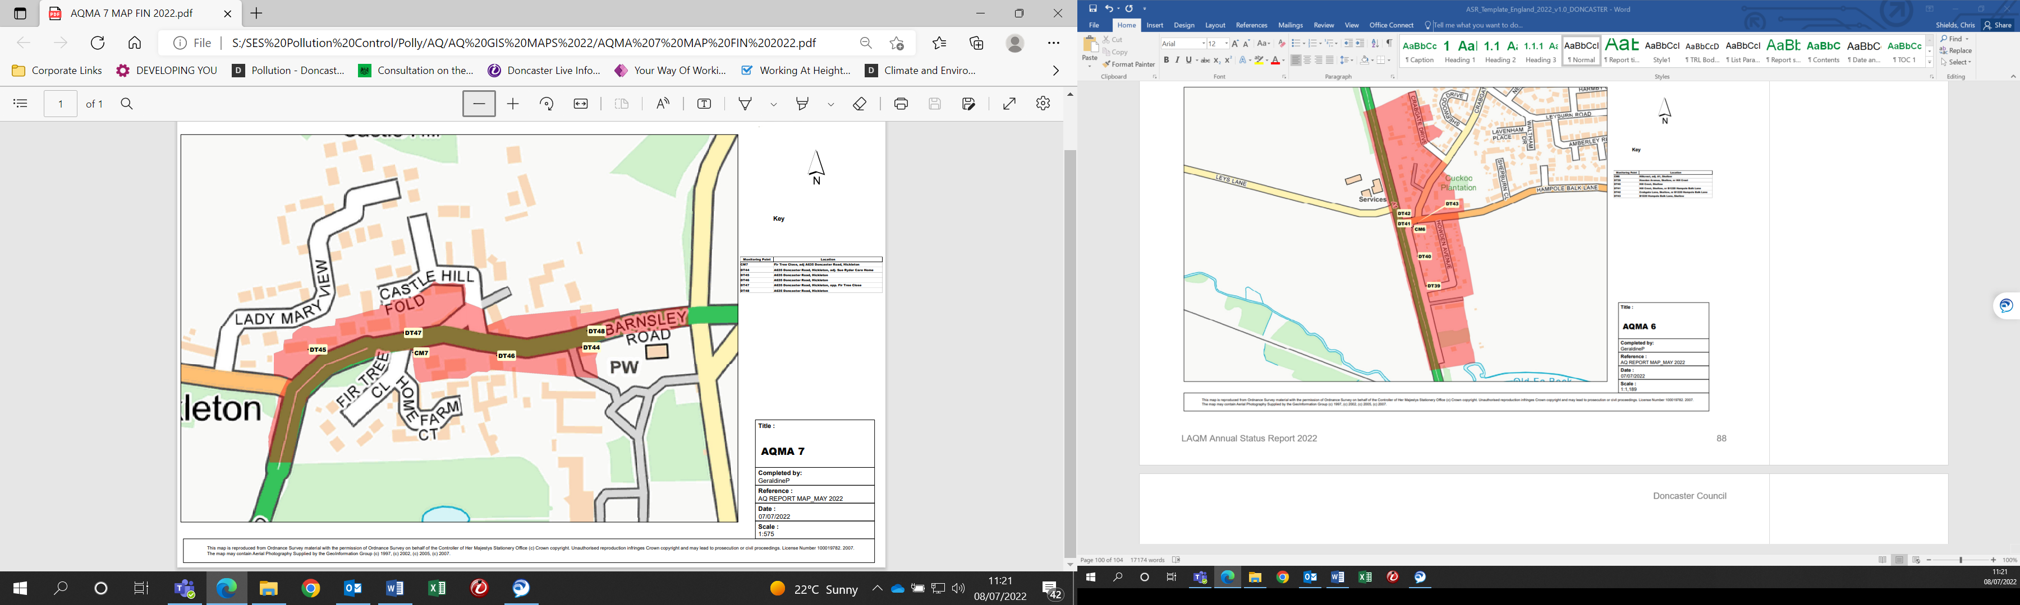

Figure 2.8 AQMA 7A Marr A635 with diffusion tube locations
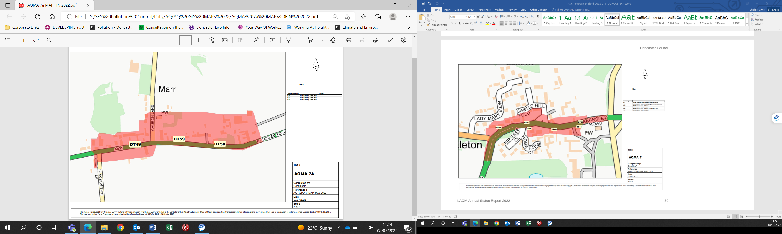

The real-world concentrations measured in Doncaster have been affected by the COVID 19 pandemic. Six of Doncaster’s AQMA’s are currently below the annual average national objective for Nitrogen Dioxide (2022) however it is important to recognise the impact of COVID 19 before looking to revoke these AQMAs.
The most recent Annual Status Report (ASR) contains the current data recorded from across Doncaster. Maps of the AQMAs and monitoring points can be found above as well as in the appendices, and further information is available on City of Doncaster Council’s website.
The measures in this action plan aim to improve air quality across all eight AQMAs, while also focussing on AQMAs 2 and 7 which are currently in exceedance of the air quality objectives. If identified as a result of further studies, specific measures may be brought forward at any time to further target individual AQMAs. Where an opportunity can be identified to improve air quality at any single location it will be made clear in any annual reports and revisions.
New measures will be added when and where appropriate to ensure the plan continues to work towards improving air quality.
The 2022 monitoring results from diffusion tubes located in the eight AQMAs are shown below in µg/m3. Exceedances of the Air Quality Objective (40µg/m3) are shown in bold.

Table 2.1 - AQMA 1, A630 Church Way
 | 2018 | 2019 | 2020 | 2021 | 2022
DT2 | 41 | 36.8 | 31.9 | 30 | 30.2
DT36 | 37 | 31.9 | 27.9 | 27.1 | 29.4
DT37 | 41 | 39 | 29.9 | 29 | 34
DT60 | 43.5 | 36.9 | 29.3 | 28.7 | 26.1
DT61 | 42 | 37 | 27.4 | 27.5 | 26.3
DT62 | 53.1 | 45.3 | 32.9 | 34.8 | 32.2
DT63 | 49.7 | 42.3 | 28.9 | 35 | 28.5
DT64 | 48.6 | 44.1 | 33.2 | 32.9 | 32.9

Table 2.2 - AQMA 2, A630 Balby Road
 | 2018 | 2019 | 2020 | 2021 | 2022
DT21 | 50 | 46.2 | 36.9 | 37.6 | 38
DT22 | 52 | 46.1 | 37.5 | 37.1 | 33.1
DT25 | 41 | 37.9 | 29.9 | 30.6 | 30.4
DT26 | 39 | 34.2 | 27.1 | 28.3 | 28.4
DT27 | 45 | 40 | 33.6 | 31.9 | 31.5
DT28 | 57 | 49 | 40.4 | 40.8 | 42

Table 2.3 - AQMA 3, A18 Carr House Road
 | 2018 | 2019 | 2020 | 2021 | 2022
DT5 | 37 | 34.7 | 27.8 | 30.7 | 33
DT65 | 38.6 | 34 | 27.7 | 26.3 | 30.1
DT66 | 42.9 | 37.5 | 30.9 | 32.9 | 31.4
DT67 | 38 | 31.8 | 26.3 | 27.6 | 25.5

Table 2.4 - AQMA 4, M18/A638 Bawtry Road, Bessacarr
 | 2018 | 2019 | 2020 | 2021 | 2022
DT13 | 41 | 38.3 | 28.8 | 30.6 | 29.6
DT68 | - | - | 16.4 | 16.9 | 16.5
DT69 | - | - | 18.2 | 18.7 | 17.3

Table 2.5 - AQMA 5, A630/Low Road, Conisbrough
 | 2018 | 2019 | 2020 | 2021 | 2022
DT23 | 40 | 37.6 | 29.8 | 28.7 | 30.2
DT24 | 43 | 39.1 | 32 | 31.2 | 32.1
DT51 | 35 | 31 | 24.3 | 24.6 | 25
DT52 | 44 | 39 | 30.9 | 33.2 | 33.9
DT53 | 43 | 36.2 | 29.1 | 30.4 | 31.4
DT54 | 47 | 44.1 | 36.1 | 37.1 | 37.3
DT55 | 34 | 31 | 23.4 | 23.6 | 23.7

Table 2.6 - AQMA 6, A1 Skellow
 | 2018 | 2019 | 2020 | 2021 | 2022
DT39 | 41 | 36.7 | 27.6 | 28.1 | 27.7
DT40 | 45 | 38.1 | 28.9 | 30.3 | 29.1
DT41 | 48 | 40.8 | 30.4 | 31.5 | 31.8
DT42 | 43 | 38 | 26.7 | 28.2 | 29.8
DT43 | 40 | 34 | 24.4 | 25.2 | 25.8

Table 2.7 - AQMA7, A635 Hickleton
 | 2018 | 2019 | 2020 | 2021 | 2022
DT44 | 70 | 67 | 50.7 | 51 | 52
DT45 | 25 | 22 | 16.8 | 15.9 | 15.3
DT46 | 40 | 35 | 24.9 | 26 | 25.8
DT47 | 91 | 76 | 59.4 | 54.1 | 54.2
DT48 | 87 | 80 | 55.8 | 55.2 | 61.1

Table 2.8 - AQMA 7A, A635 Marr
 | 2018 | 2019 | 2020 | 2021 | 2022
DT58 | 43 | 38 | 31.6 | 29.8 | 30.6
DT59 | 23 | 20 | - | 13.4 | 13.1
DT49 | 43 | 37 | 27.4 | 28.3 | 28.1

Below are charts illustrating the general trend of monitored results over the past 5 years. It is again important to consider the impact of the Covid 19 pandemic when viewing this trend.

Once the 2023 monitoring data is available the City of Doncaster Council will assess whether the AQMAs currently in compliance with the objectives can be revoked. This additional year of data will allow the Council to better gauge the monitored concentrations and current trends post pandemic.

General air quality trends in Doncaster’s AQMAs

Figure 2.9 Annual Mean NO2 Concentration (µg/m3), AQMA 1
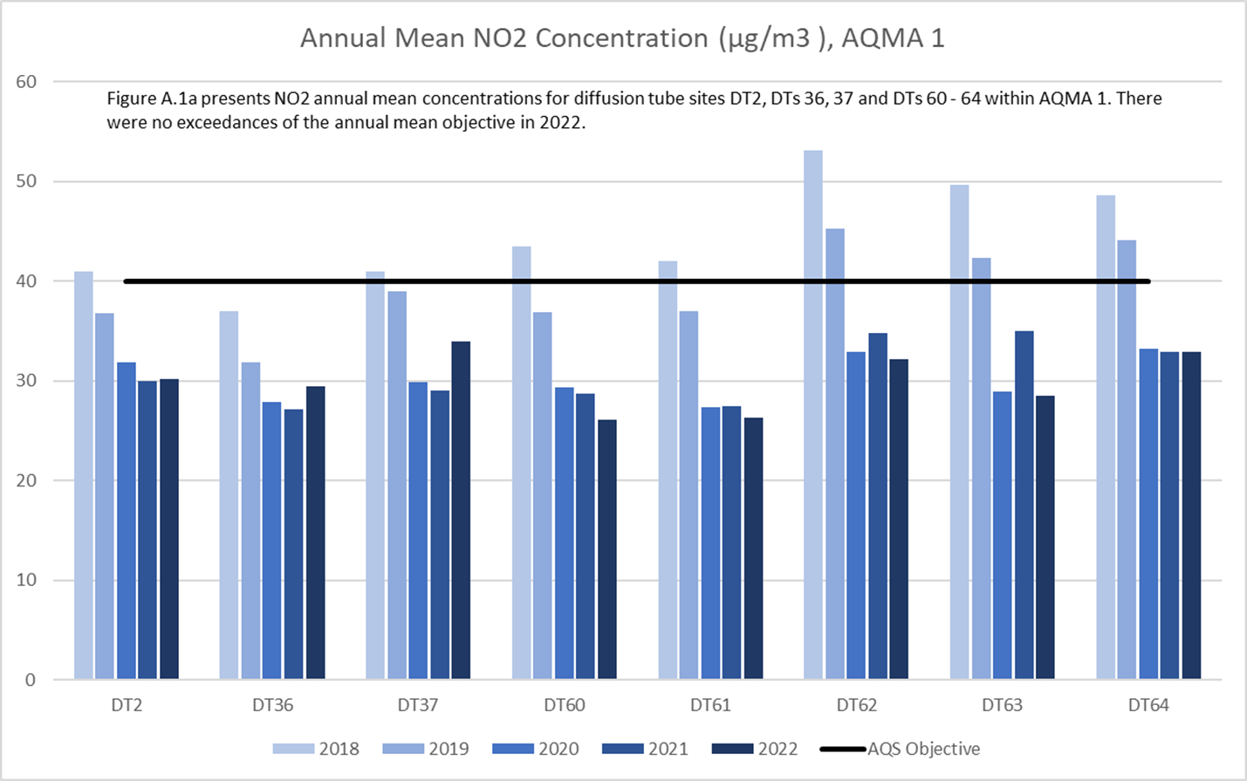

Figure 2.10 Annual Mean NO2 Concentration (µg/m3), AQMA 2
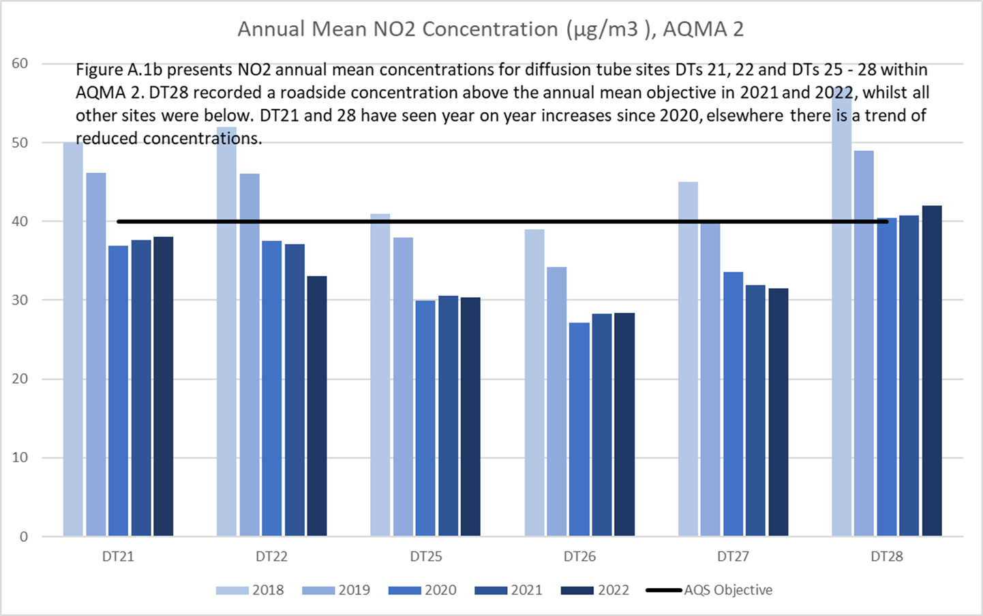

Figure 2.11 Annual Mean NO2 Concentration (µg/m3), AQMA 3
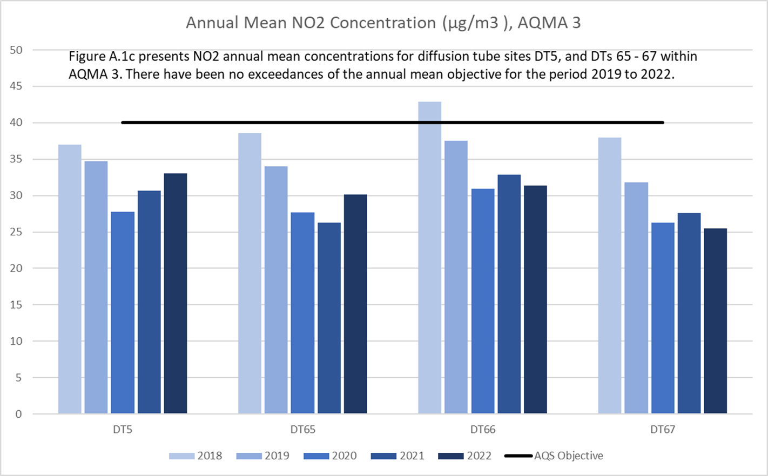

Figure 2.12 Annual Mean NO2 Concentration (µg/m3), AQMA 4
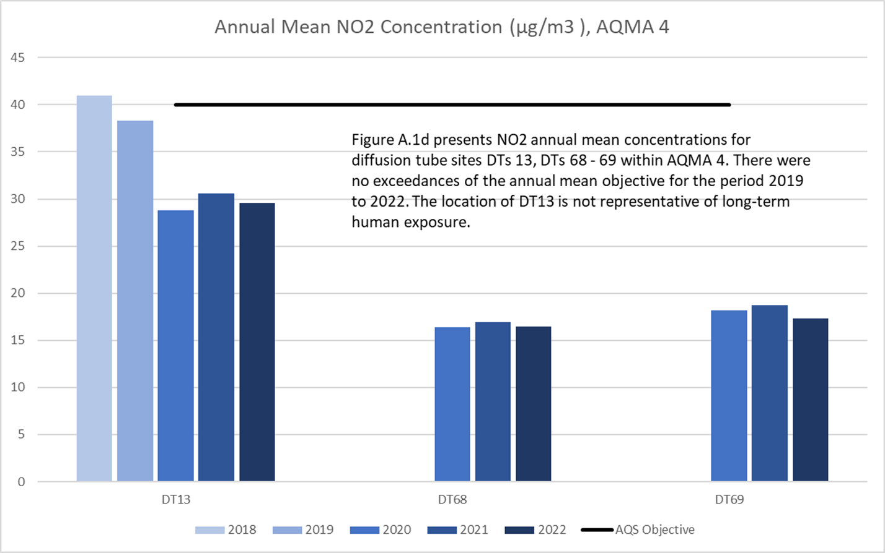

Figure 2.13 Annual Mean NO2 Concentration (µg/m3), AQMA 5
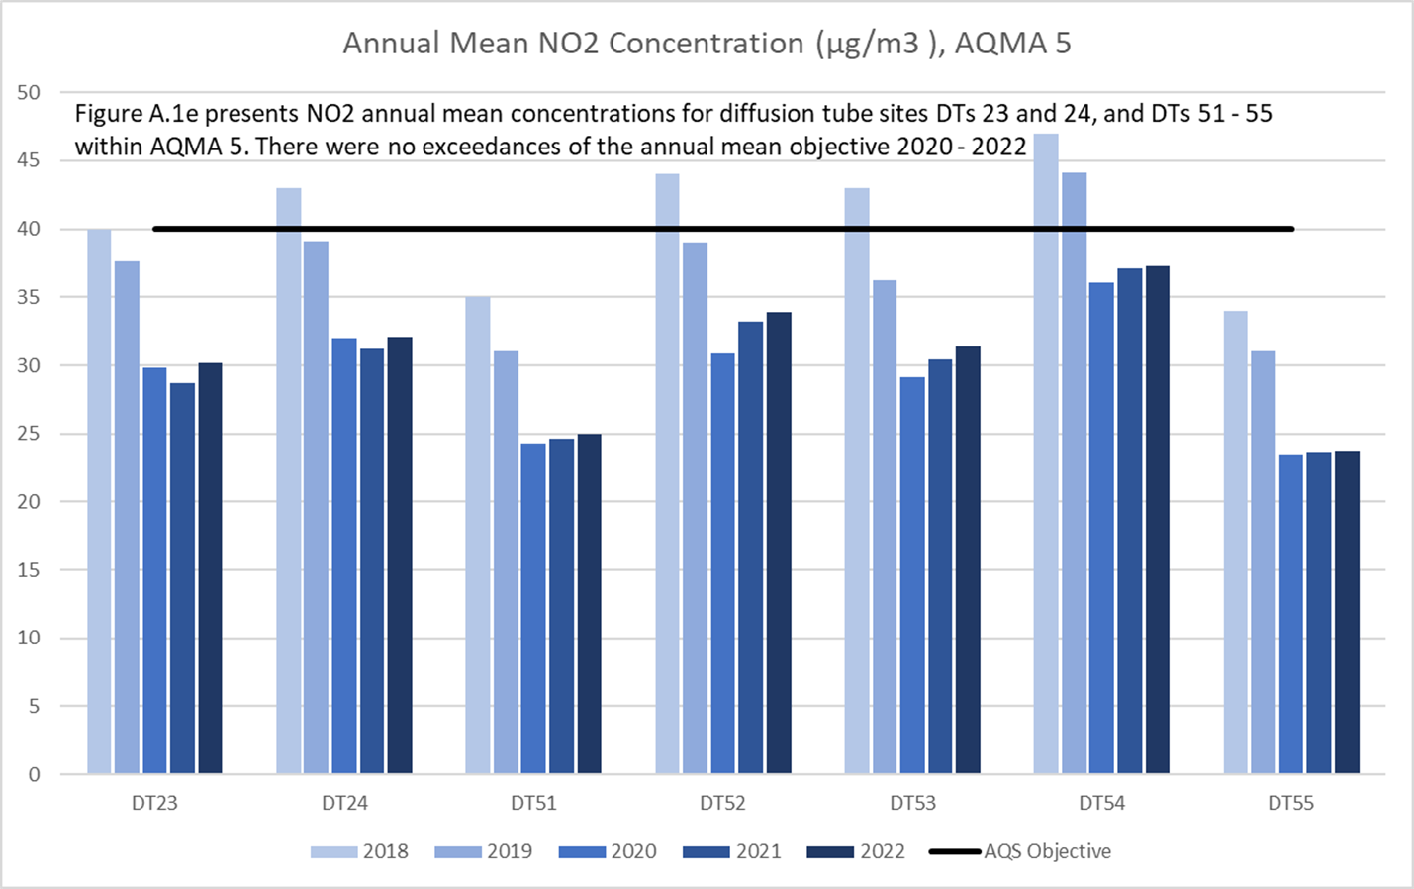

Figure 2.14 Annual Mean NO2 Concentration (µg/m3), AQMA 6
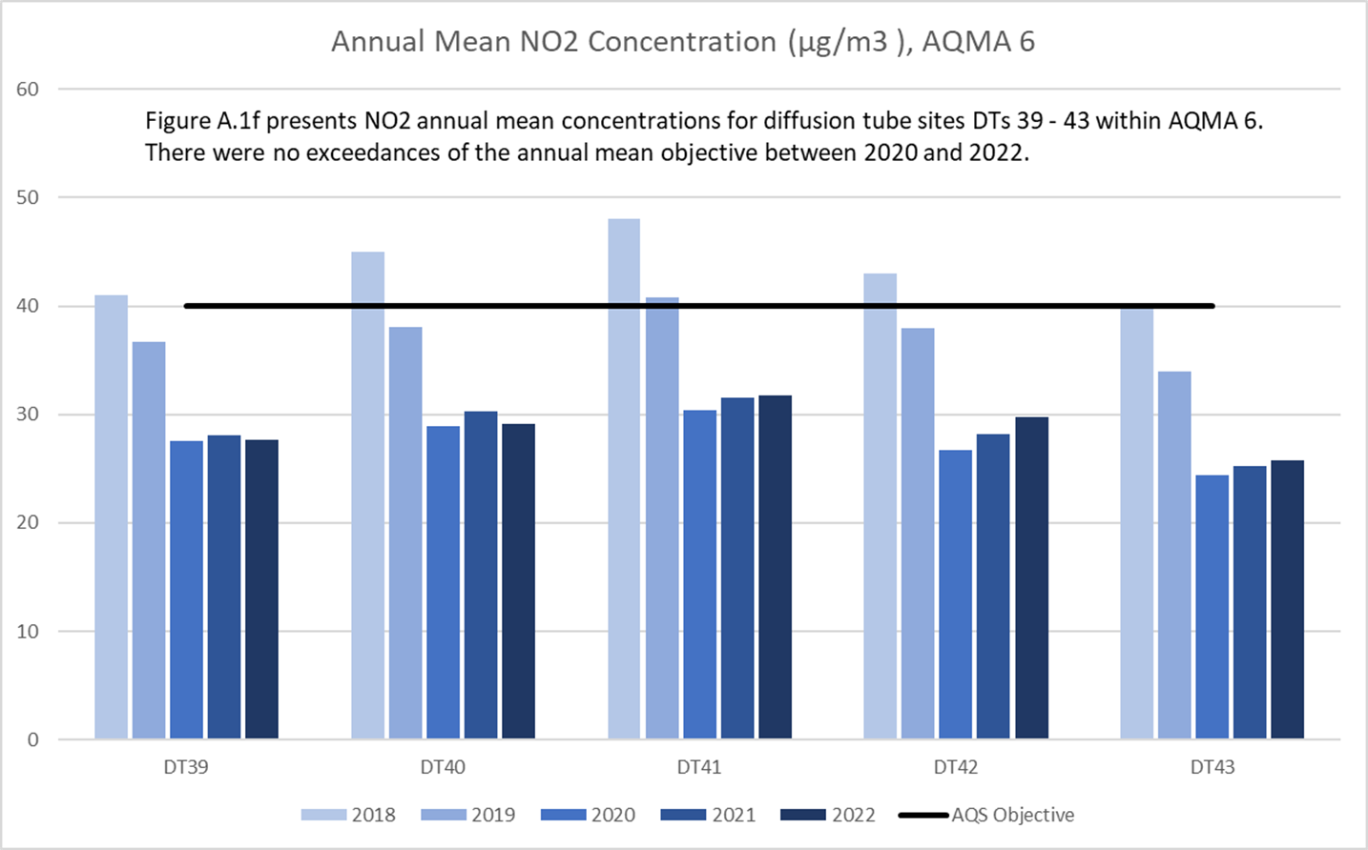

Figure 2.15 Annual Mean NO2 Concentration (µg/m3), AQMA 7
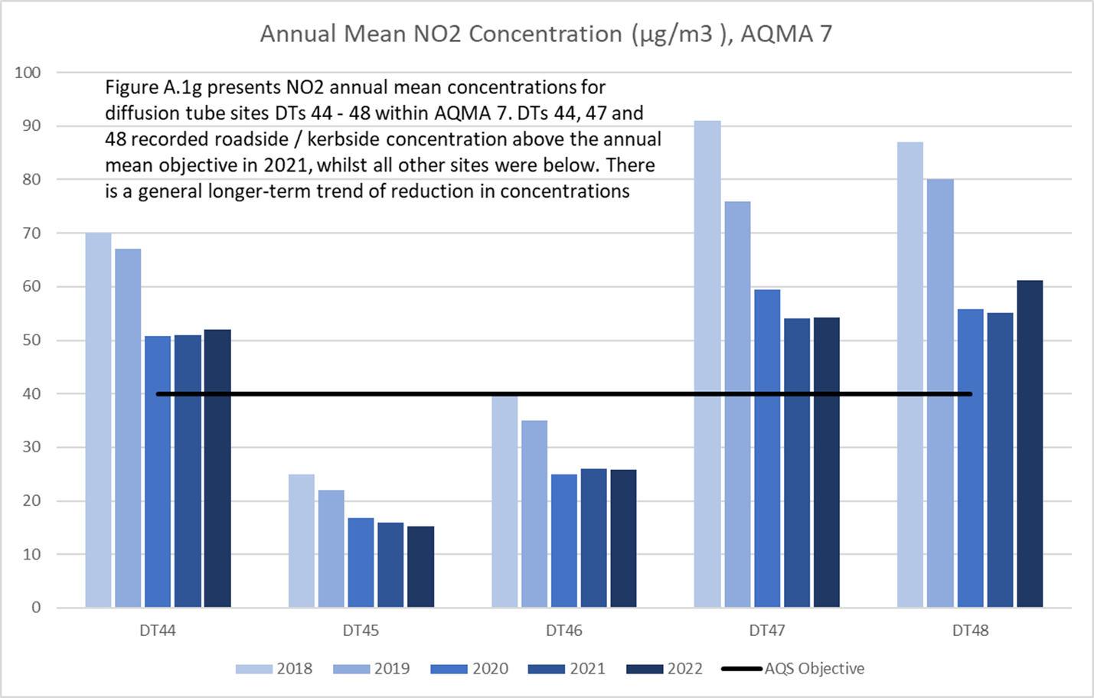

Figure 2.16 Annual Mean NO2 Concentration (µg/m3), AQMA 7A
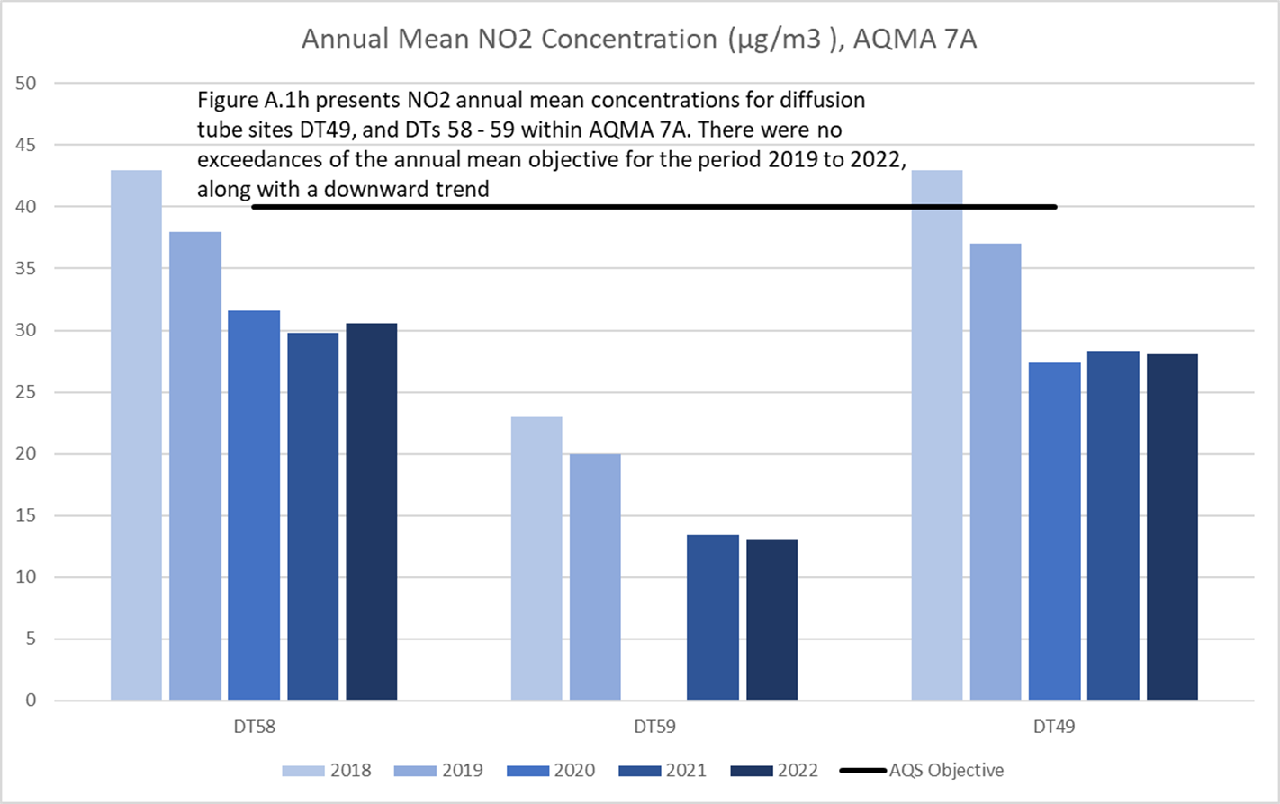

3. City of Doncaster Council’s Air Quality Priorities
Public Health Context
In the UK, air pollution is the largest environmental risk to public health.
Air pollution can cause and worsen health effects in all individuals, particularly society’s most vulnerable populations. Long-term exposure to air pollution can cause chronic conditions such as cardiovascular and respiratory diseases as well as lung cancer, leading to reduced life expectancy. Short-term increases in levels of air pollution can also cause a range of health impacts, including effects on lung function, exacerbation of asthma, increases in respiratory and cardiovascular hospital admissions and mortality.
Air Pollution explained
Air pollution is a substance or complex mixture of particles and gases in the air that cause harm to people’s health. Air pollutants are emitted from both natural and human sources.
Damaging air pollutants, for which there are national emission reduction commitments, are fine particulate matter (PM_{2.5}), ammonia (NH₃), nitrogen dioxide (NO₂), sulphur dioxide (SO₂), and non-methane volatile organic compounds (NMVOCs). Other ambient (outdoor) air pollutants include ozone and carbon monoxide (CO).
Ambient air pollution originates from sources including transport, industrial processes, farming, energy generation and domestic heating. Concentrations of air pollutants can vary both temporally and spatially but are typically higher close to the source. In urban areas especially, concentrations of particulate matter and NO₂ can be particularly high.
The health impacts of air pollution
The health effects of pollutants will depend on many factors as to the level of harm an individual is exposed to. This includes the dose, duration, how an individual comes into contact with the pollutant, in addition to factors such as age, sex, diet, family traits, lifestyle and state of health.

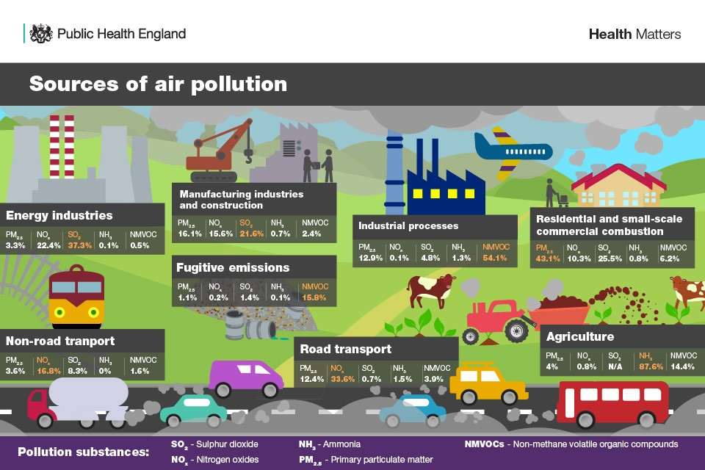
Air pollution can affect the eyes, nose and throat, the heart and associated blood vessels and the lungs and respiratory system. Short-term exposure (over hours or days) can lead to a range of health impacts including lung function, coughing, wheezing and shortness of breath, exacerbation of asthma, increases in respiratory and cardiovascular hospital admissions and mortality. Over long timescales (years or lifetimes) exposure can lead to reduced life expectancy, due to cardiovascular diseases, respiratory diseases, and lung cancer. More recent research has associated air pollution with affecting the brain causing dementia and cognitive decline; diabetes and affecting early life leading to various birth outcomes, for example, low birth weight and developmental problems.
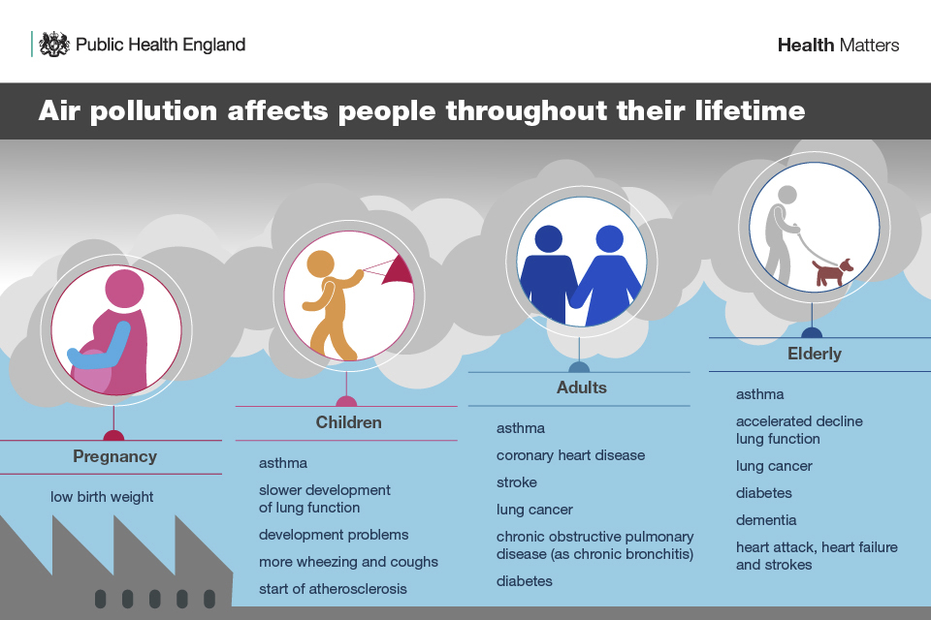Air pollution can affect anyone’s health; nevertheless, some individuals can be more susceptible than others. These include:
- children
- the elderly
- individuals with existing cardiovascular or respiratory diseases
- pregnant women
- communities in areas of higher pollution, such as close to busy roads
- low-income communities

No update on the current situation in Doncaster was available at time of writing this report however the most recent information is presented below.
The Public Health Framework indicator for mortality attributable to PM_{2.5} for Doncaster stands at 5% which is lower than the national average. Monitoring is now conducted in Doncaster at four continuous monitoring stations and these results fell below the current objective.
Public Health England developed a methodology to demonstrate how these figures relate to deaths by Council area. In 2010 it was estimated that 160 deaths in the 25+ age group could be attributed to PM_{2.5} in Doncaster or an associated loss of 1706 life years.
The Council’s Air Quality Steering Group of cross Directorate officers hold regular meetings to consider air quality and work collaboratively on issues that impact air quality.

Planning and Policy Context
The new Local Plan for Doncaster was adopted in September 2021; a policy relating to air quality has been incorporated within the Plan and will be applied to all development within Doncaster.
Policy 13: Promoting Sustainable Transport in New Developments (Strategic Policy) Proposals are required to meet the following requirements:
A) New development shall make appropriate provision for access by sustainable modes of transport to protect the highway network from residual vehicular impact. The Council will work with developers to ensure that:
1. access to the development can be made by a wide choice of transport modes, including walking, cycling, and the private car, and public transport where appropriate;
2. site layouts and the street environment are designed to control traffic speed through an appropriate network and street hierarchy that promotes road safety for all; 3. walking and cycling are encouraged within the development and beyond, through the design of facilities and infrastructure within the site and provision of linkages to the wider network;
4. appropriate levels of parking provision are made in accordance with the standards contained within Appendix 6. A departure from these standards may be justified on a case by case basis, for example reduced parking levels for Town Centre residential developments where accessibility to public transport is more prevalent. Developments should also include provision for electric vehicle charging points, with fast charging infrastructure provided for use by short stay users where appropriate;
5. residential developments should provide dedicated cycle storage for each property. For houses, this could be in adequately sized garages or bike sheds. For flats or apartments, this may be shared dedicated secure facilities. Non-residential developments are required to provide cycle parking spaces to the equivalent of at least 10% of car parking spaces as set out in Appendix 6. Any departure from the standards for car parking provision should not be reflected in the reduction of cycle parking provision and, where appropriate, this should be increased in locations where cycling infrastructure encourages higher levels of cycling; and
6. development does not result in unacceptable impact on highway safety, or severe residual cumulative impacts on the road network. Developers must consider the impact of new development on the existing highway and transport infrastructure. Where necessary, developers will be required to mitigate (or contribute towards) any predicted adverse effects on the highway and the wider transport network.
B) New developments will need to provide, as appropriate, Transport Statements, Transport Assessments and Travel Plans to ensure the delivery of travel choice and sustainable opportunities for travel in line with the latest government guidance and best practice. Thresholds for when these documents are required are set out in Appendix 7.
New developments that are predicted to have an adverse impact on the transport network will be expected to contribute towards capacity and mitigation measures. Proposals that require new projects will be required to make a proportionate financial contribution.
In addition, proposals should include details of post-development monitoring of traffic and mitigation measures in the event that traffic levels agreed through the original permission are later exceeded.
Policy 54: Pollution
Development proposals that are likely to cause pollution, or be exposed to pollution, will only be permitted where it can be demonstrated that pollution can be avoided, or where mitigation measures (such as those incorporated into the design and layout of development) will minimise significantly harmful impacts to acceptable levels that protect health, environmental quality and amenity. When determining planning applications, the agent of change principle will be applied, and particular consideration will be given to:
A) an assessment of the risks to public health and the impact of cumulative effects and where necessary that the provision for mitigation against the total effects has been provided.
B) the presence of noise generating uses close to the site, and the potential noise likely to be generated by the proposed development. A Noise Assessment will be required to enable clear decision-making on any relevant planning application. Proposals will need to have regard to the standards identified in Appendix 11 to establish is the proposal is acceptable in noise impact terms.
C) the impact on national air quality; especially but not limited to Air Quality Management Areas, areas potentially close to the EU limit value, other sensitive areas and the aims and objectives of the Air Quality Action Plan. An Air Quality Assessment will be required to enable clear decision making on any relevant planning application.
D) any adverse effects on the quantity, quality and ecology features of water bodies and groundwater resources, including contamination to Source Protection Zones.
E) the impact of artificial lighting. Artificial lighting has the potential to cause unacceptable light pollution in the form of sky-glow, glare or intrusion onto other property and land. Development proposals should ensure that adequate and reasonable controls to protect dwellings and other sensitive property, the rural night-sky, observatories, road-users, and designated sites for conservation of biodiversity and protected species are included within the proposals.
The Local Plan contains other polices which will contribute to the air quality agenda, such as polices regarding sustainable and active travel, reducing the need to travel, suitable and considered allocations of sites, green infrastructure and health impact assessments.
A technical planning guidance document has been produced and is used within the Environmental Protection Team. The aim is to ensure mitigation is an integral part of any development proposals in order to maintain and where possible improve local air quality. This is done via screening of development proposals, calculation of emissions and damage costs and mitigating those emissions.

Source Apportionment
The AQAP measures presented in this report are intended to be targeted towards the predominant sources of emissions within City of Doncaster Council’s area if possible.
A source apportionment exercise was carried out by City of Doncaster Council in 2023. This identified that within the AQMA, the percentage source contributions were as follows:

Figure 3.1 AQMA 1 Road NOx Source Apportionment

Figure 3.2 AQMA 2 Road NOx Source Apportionment

Figure 3.3 AQMA 3 Road NOx Source Apportionment
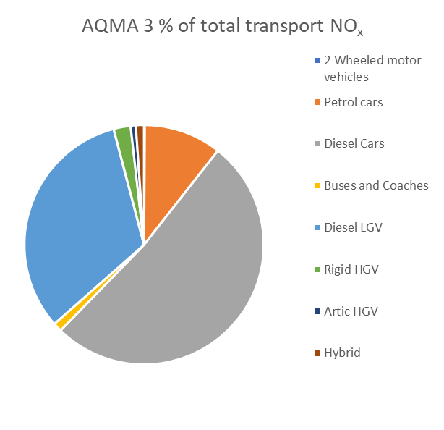

Figure 3.4 AQMA 4 Road NOx Source Apportionment
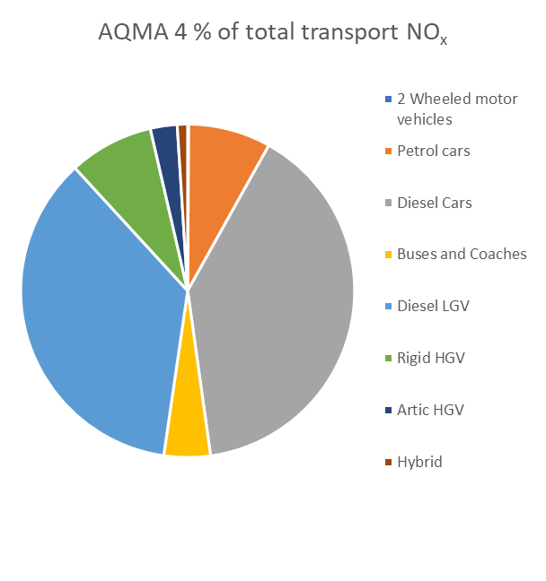

Figure 3.5 AQMA 5 Road NOx Source Apportionment
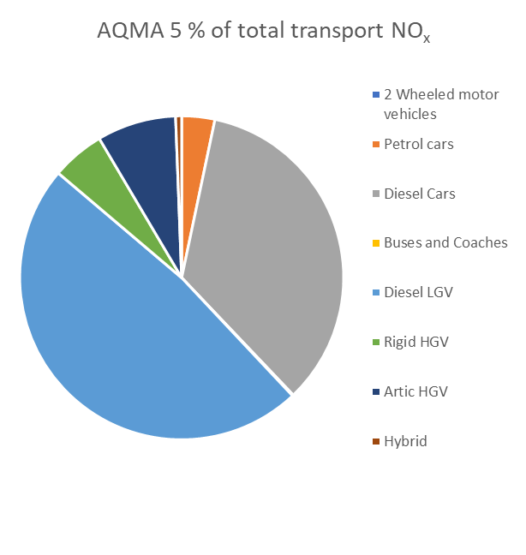

Figure 3.6 AQMA 6 Road NOx Source Apportionment
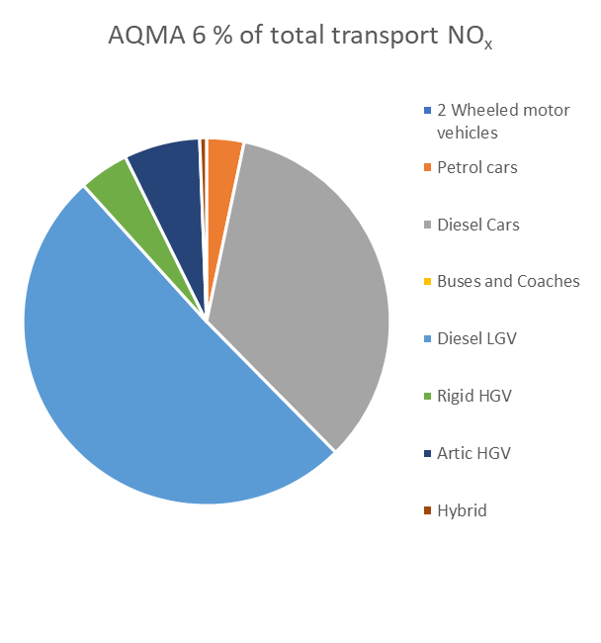

Figure 3.7 AQMA 7 Road NOx Source Apportionment
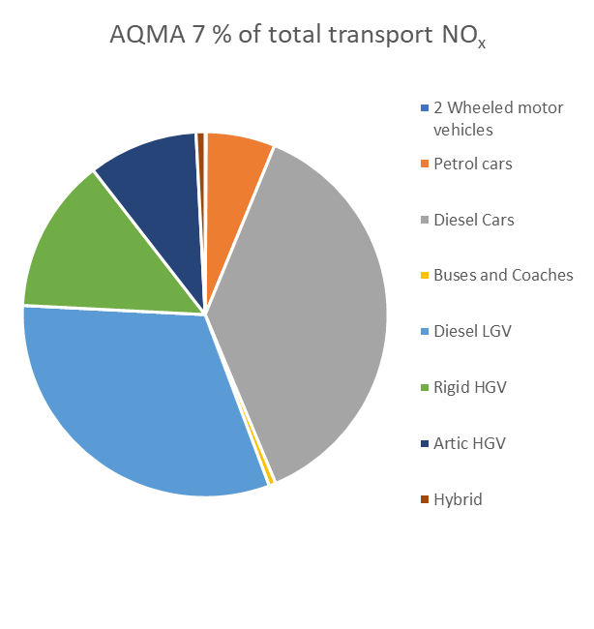

Figure 3.8 AQMA 7A Road NOx Source Apportionment
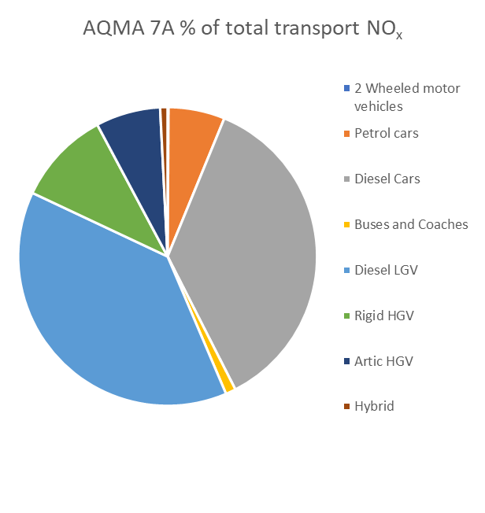
All AQMAs in Doncaster are the result of road traffic emissions.
The above charts (figures 3.1-3.8) show that Diesel vehicles are the primary source of emissions in Doncaster’s AQMAs. Diesel cars and LGV account for between 69% and 84.4% of emissions within the AQMAs.
HGVs account for between 3% (AQMA 3) and 23.4% (AQMA 7) of emissions.
Specific sources such as diesel vehicles or HGVs are difficult to target with measures due to their widespread use. Effective targeting of these specific sources would require further study to identify and assess additional factors such as the euro classification of vehicles and options to promote available alternatives.
It is believed that measures such as scrappage schemes would reduce emissions by promoting a change to cleaner more efficient vehicles however these are the domain of central government rather than local government.
Measures contained within this and previous AQAPs have been designed to address these sources of emissions where possible. City of Doncaster Council will work to highlight the emissions from different classification of vehicles through schemes and events such as Clean Air Day.
In 2022 City of Doncaster Council commissioned Ricardo Energy and Environment to undertake a Vehicle Emission Study and Further Assessment (modelling study) for AQMA 7 as this AQMA is experiencing the highest concentrations of Nitrogen Dioxide. These reports have been made available to the public on the City of Doncaster Council website http://www.doncaster.gov.uk/services/environmental/air-quality-reports-available-to-the-public.
The Ricardo studies have allowed City of Doncaster Council to consider a more accurate and detailed source apportionment when formulating measures to address the exceedance of the Nitrogen Dioxide objective in AQMA 7. A more in-depth discussion of this information and its implications is provided in appendix E.
A Clean Air Zone class D (CAZ) was specifically assessed as a measure for AQMA 7 via the reports by Ricardo and was found to not achieve compliance with the Air Quality Standards significantly sooner than the natural greening/turnover of the fleet, including the upcoming government ban of petrol and diesel engine cars. Measure 1 below (table 5.1) proposes similar in-depth studies for AQMA 2 to increase our understanding of emissions and also consider the need and effectiveness of further measures.
City of Doncaster Council has been extending cycling routes to include access to Adwick Station, Bentley Station, Kirk Sandall Station, Edlington Connector, West Moor Link Active Travel, Conisbrough to Warmsworth A630 and the Mill Lane, Harlington to Pastures Road, Mexborough Trans Pennine Trail Improvements. While some of these improvements will have a direct influence on an AQMA (such as Conisbrough), other improvements will encourage the uptake of cycling which may remove vehicles which would transit through an AQMA.
The introduction of the Doncaster Air Quality Technical Planning Guidance as part of measures included in the previous AQAP (2018) has secured the installation of EV chargers at new developments through planning conditions. This increase in EV charger availability will encourage residents to change from diesel vehicles towards EV vehicles.

To identify which emissions could be successfully targeted with measures it is important to apportion the NO₂ sources into emissions from local sources such as road traffic, local background and regional background.
Local sources will add to the background to give rise to the hotspot area of exceedances. These will be the principal sources for the local authority to control within the Action Plan.
Local background is a contribution to the total background which the authority should have some influence over.
Regional background is a source upon City of Doncaster Council is unable to influence.

Figure 3.9 Source Apportionment of NO₂ concentrations in AQMA 1
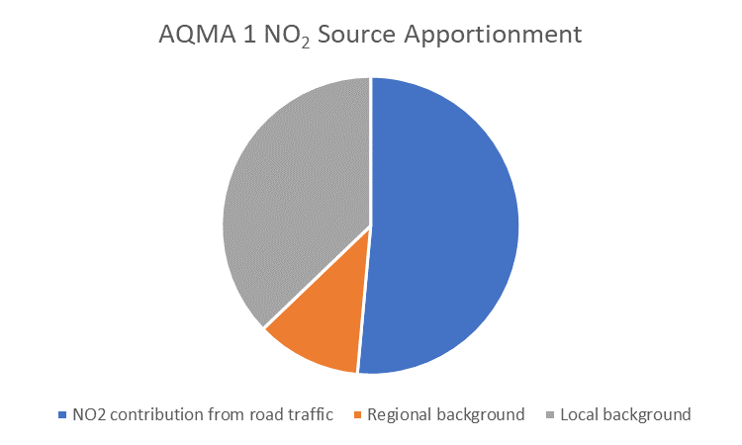

Figure 3.10 Source Apportionment of NO₂ concentrations in AQMA 2
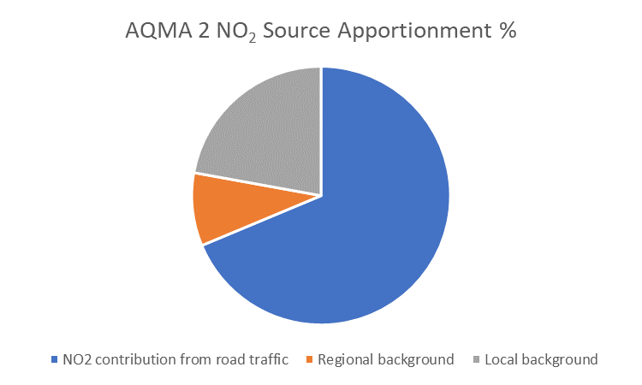

Figure 3.11 Source Apportionment of NO₂ concentrations in AQMA 3
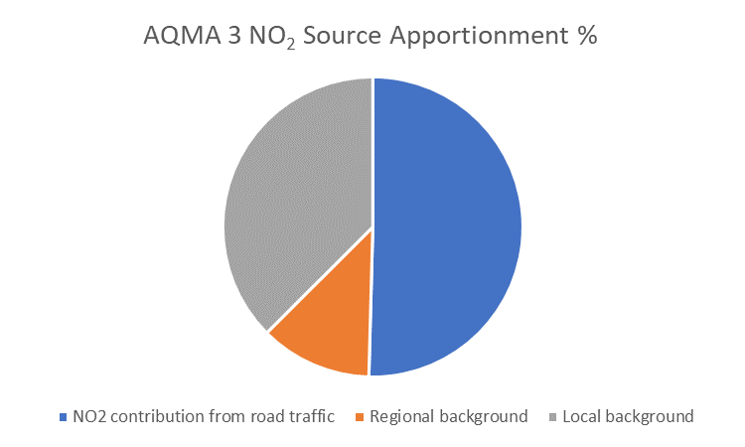

Figure 3.12 Source Apportionment of NO₂ concentrations in AQMA 4
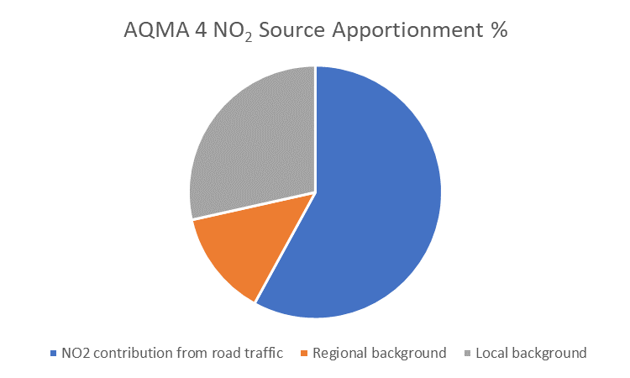

Figure 3.13 Source Apportionment of NO₂ concentrations in AQMA 5

Figure 3.14 Source Apportionment of NO₂ concentrations in AQMA 6
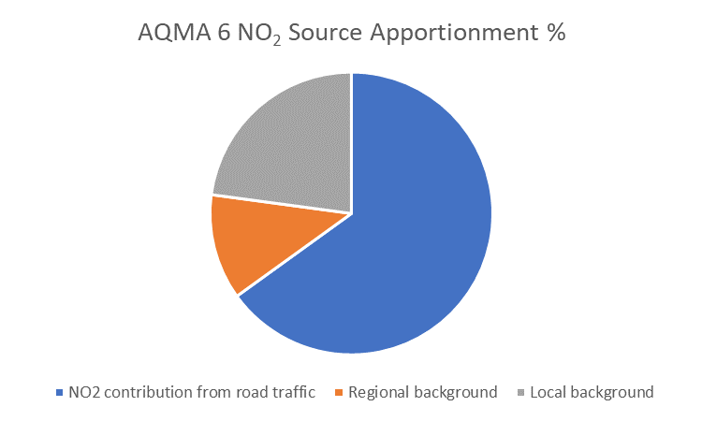

Figure 3.15 Source Apportionment of NO₂ concentrations in AQMA 7
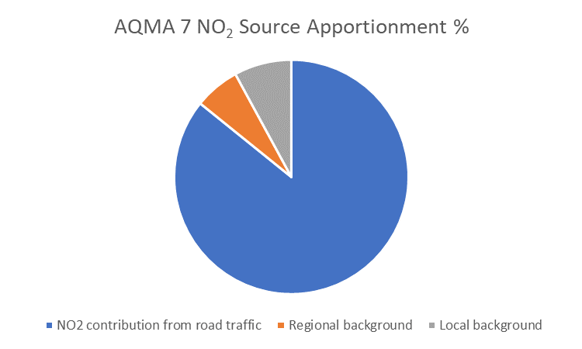

Figure 3.16 Source Apportionment of NO₂ concentrations in AQMA 7A
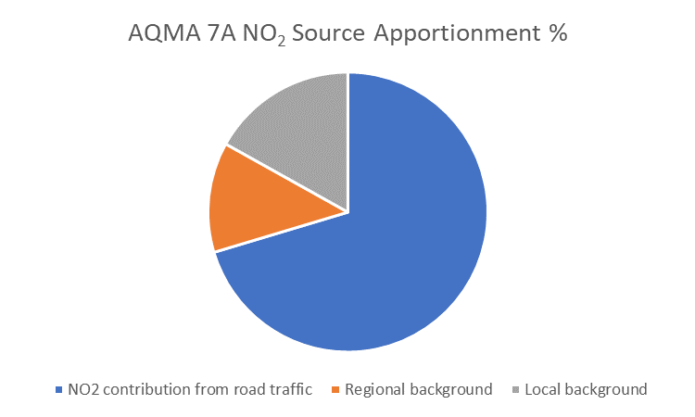
As can be seen from figures 3.09 to 3.16 road traffic emissions makes up the majority of emissions in all AQMAs ranging from 50.4% in AQMA 3 to a high of 85.81% in AQMA 7.
Local background contributed between 7.94% in AQMA 7 to 37.5% in AQMA 3.
Regional background accounted for between 6.25% in AQMA 7 and 13.55% in AQMA 4.
These results suggest that successful targeting of emissions from road traffic in AQMA 2 (68.69%) and AQMA 7 (85.81%) which are currently in exceedance, should have a significant impact on overall concentrations experienced in those AQMAs.
Required Reduction in Emissions
Table 3.1 below presents the required reduction in Nitrogen Dioxide to achieve compliance with the annual average national objectives.
The required reduction in emissions assessment (shown below) used diffusion tubes which have recorded the highest concentrations of NO₂ within the AQMAs in 2022. Of these tubes DT28, DT41, DT48, DT54, and DT64 are located on or close to residential properties and as such are considered representative of exposure.
DT5 and DT13 are not located at residential properties instead being located at points of highest concentrations.
DT5 has similar readings to the other tubes in AQMA 3 (33µg/m3 against, 30 µg/m3, 31µg/m3 and 26µg/m3).
DT13 is located on a motorway bridge to capture emissions from the M18. Two other tubes are located in AQMA 4, DT68 is located on a residential property close to the motorway and has recorded concentrations significantly lower (16µg/m3) than DT13 (30µg/m3). DT69 is located on a nearby footbridge over the M18 and has recorded similarly low concentrations (17µg/m3), therefore the decision was made to use DT13 for the assessment.

Table 3.1 Emission Reductions Required to Achieve Compliance with the Air Quality Objectives in (µg/m3)
AQMA | 2022 Diffusion tube Results at highest monitoring point | Reduction of NO₂ in (µg/m3)
1 Market (DT64) | 34 | -6
2 Balby Road (DT28) | 42 | 2
3 Carr House Road (DT5) | 33 | -7
4 Bessacarr (DT13) | 30 | -10
5 Conisbrough (DT54) | 37 | -3
6 Skellow (DT41) | 32 | -8
7 Hickleton (DT48) | 61 | 21
7A Marr (DT58) | 31 | -9

Emissions reduction calculations have been undertaken (Table 3.2 following the procedure set out in LAQM.TG(22).

Table 3.2 Road NOx Emission Reductions Required to Achieve Compliance with the Air Quality Objectives (%)
AQMA | 2022 Diffusion tube Results at highest monitoring point in Road NO_{x} | Objective in Road NO_{x} | Required reduction in Road NO_{x} to meet objective (% of measured road NO_{x})
1 Market | 35.86 | 49.16 | -17.63
2 Balby Road | 53.87 | 49.27 | 26.54
3 Carr House Road | 34.91 | 50.4 | -17.59
4 Bessacarr | 34.33 | 61.23 | -33.25
5 Conisbrough | 54.3 | 56.45 | -19.38
6 Skellow | 41.21 | 59.19 | -24.39
7 Hickleton | 118.01 | 63.72 | 75.2
7A Marr | 43.95 | 64.31 | -28.26

The results in Tables 3.1 and 3.2 show the level of intervention needed from road transport to reach compliance. In most cases, compliance has already been reached within AQMAs (using the prescribed methodology), while other locations close to the busiest roads will require significant action to achieve acceptable air quality. As such the proposed measures in Table 5.1 will focus on identifying actions to be undertaken in these AQMAs 2 and 7 to achieve compliance.
Key Priorities
The key priorities for City of Doncaster Council to improve air quality based on the information gathered and the results discussed in Section 3.3 and 3.4 are;
- Encourage fewer journeys by diesel cars by promoting alternative fuelled vehicles and modal shift particularly to active travel (All AQMAs)
- Ensuring new development mitigates additional emissions (All areas and wider background)
- Continue to work with Bus Operators and encourage operators to apply for funding for cleaner vehicles (All AQMAs)
- Investigating the feasibility of innovative and impactful measures to address the exceedance of air quality objectives in AQMA 7.
- Conduct studies in AQMA 2 to gain a more complete understanding of concentrations and source apportionment prior to formulating specific measures appropriate to achieve compliance with the objectives.

4. Development and Implementation of City of Doncaster Council AQAP
Consultation and Stakeholder Engagement
In developing this AQAP, we have worked to improve local air quality. Schedule 11 of the Environment Act 1995 requires local authorities to consult the bodies listed in Table 4.1. In addition, we have undertaken the following stakeholder engagement:
- Doncaster Council Website
- Directly to residents as requested.
- Directly to the Chamber of Commerce
- Sheffield City Region through the Air Quality and Climate Group
The response to our consultation stakeholder engagement is given in Appendix A: Response to Consultation.

Table 4.1 ‒ Consultation Undertaken
Consultee | Consultation Undertaken
The Secretary of State | No
The Environment Agency | No
The highways authority | No
All neighbouring local authorities | No
Other public authorities as appropriate, such as Public Health officials | No
Bodies representing local business interests and other organisations as appropriate | No

Steering Group
A steering group was officially formed by an inaugural meeting of its members on the 20th April 2017.
The terms of reference have been agreed and are attached in the appendix C.
Officers from across key departments of the Authority have been invited onto the group; in particular;
- Transport
- Highways
- Environmental Protection
- Planning
- Public Health
The group have agreed that outside stakeholders will be engaged following consultation and welcome further measures to be incorporated where appropriate.
The steering group will ensure that progress on actions is reported each June via the Annual Status Report. The AQAP is a working document and as further information, measures and/or funding are available they will be considered by the steering group.

5. AQAP Measures
Table 5.1 shows the City of Doncaster Council AQAP measures. It contains:
- a list of the actions that form part of the plan
- the responsible individual and departments/organisations who will deliver this action
- estimated cost of implementing each action (overall cost and cost to the local authority)
- expected benefit in terms of pollutant emission and/or concentration reduction
- the timescale for implementation
- how progress will be monitored
NB: Please see future ASRs for regular annual updates on implementation of these measures

Measure 1 – Clean Air Feasibility Study
This measure is specifically targeted at AQMA 2. Following the successful completion of the Ricardo reports for AQAM 7, City of Doncaster Council have been able to assess measures such as Class D CAZ and 20mph speed limits and identify measures which are projected to not be sufficient to address the exceedance of the Air Quality Standards. As such a similar study in AQMA 2 will allow City of Doncaster Council to assess what measures are required and what other measures may not be as effective as expected. This will allow City of Doncaster Council to make an informed business case when seeking agreement for implementation.

Measure 2 – Investigate Roadvent
Roadvent is a new product by Pollution Solution to address concentrations of Air Pollution. Roadvent is designed to pull dirty air into the Roadvent slots installed in the road and clean that air through filters before discharge back to atmosphere. It is envisaged that this product could be installed in the road at AQMA 7 in Hickleton to reduce concentrations in an area with limited roadside space. As this product is yet to be installed in a running highway further investigation is required to assess its wearability/suitability in AQMA 7 which has a relatively high concentration of HGVs (23.4%). As this measure is a new product no data is available for modelling of predicted reduction in concentration on a running highway however trials in a drive thru scenario have identified reduction of up to 91%.

Measure 3 – Investigate removing receptors
Removing receptors is specifically proposed for AQMA 7 where the Ricardo Further Assessment Report has identified a limited number of properties which are in exceedance of the objective. As such this presents the opportunity to remove these receptors by purchasing the properties and therefore removing residents’ exposure to the high levels of NO₂. Investigations would be required to engage with local residents to assess how receptive they would be to this measure. Investigation into the financial resources would also be required to assess the feasibility of the measure.

Measure 4 – Cycling Strategy
Measure 4 is an active scheme that has been carried over from the previous AQAP. Improvements in the cycling infrastructure (which includes new cycle lanes and an active travel hub which provides cycle parking and electric bike rental) acts towards encouraging a modal shift away from petrol and diesel vehicles towards zero emission modes of transport. This measure will benefit AQMAs and Doncaster as a whole.

Measure 5 – Enhanced Bus Partnership
This scheme has introduced a £2 flat fare to encourage uptake and a move away from private vehicles. An electric bus scheme across South Yorkshire is ongoing which will see one or two buses running between Doncaster and Rotherham, these are currently on order. This scheme will help to prove the viability of electric buses and hopefully promote their use across Doncaster and its AQMAs in particular. In addition, the Quality Bus Partnership will also include a marketing campaign to increase bus patronage and look to reduce bus journey times and improve reliability which again will promote a move to public transport and reduce private vehicle usage.

Measure 6 – Walking Strategy
City of Doncaster Council will refresh its walking strategy to encourage active travel and a modal shift away from private vehicle use. This measure will provide benefits to Air Quality both in the AQMAs and Doncaster as a whole.

Measure 7 – Alternative fuelled infrastructure
City of Doncaster Council are in the process of securing external partners to facilitate the private development of alternative fuelled infrastructure. It is the hope that once installed this infrastructure will encourage the uptake of alternative fuelled vehicles particularly with respect to HGVs. It would be difficult at this stage to estimate the impact this measure may have on emissions in AQMAs as no locations or usage predictions are available. This measure has the potential to benefit all AQMAs and Doncaster as a whole.

Measure 8 - Council Fleet Improvements
This measure involves the replacement of petrol and diesel vehicles in the council fleet with zero emission electric vehicles to reduce emissions. As council vehicles are required to access all areas of the borough, they will inevitably transit through the AQMAs and therefore reducing emissions would be of benefit in reducing concentrations. The council fleet is not considered to be a significant contributor in any AQMA however this measure is within the council’s control and the visible presence of electric council vehicles will also promote the uptake of cleaner vehicles. A fleet renewal plan will aim to replace at least 600 vehicles with electric alternative before 2030.

Measure 9 - Taxi licensing regime policies to encourage cleaner taxi fleets
This measure was included in the previous AQAP (2018) yet suffered from a lack of engagement. As proposals to enact this measure remain it has been included in this AQAP in the hope it can be brought forward and lead to fewer emissions from the taxi fleet. As there are uncertainties around this measure it has been included with low priority.

Measure 10 – Hickleton and Marr Bypass
This measure would look to create a new road to provide an alternative route to transiting through Hickleton and Marr thereby removing vehicle emissions away from sensitive receptors such as residents. This measure was assessed under the previous AQAP but did not meet funding requirements. The Hickleton and Marr Bypass has since been mentioned as a potential scheme under Network North. However, a fresh assessment would take time and even if successful where the previous assessment failed, it is considered unlikely to be operational before the AQMA achieves compliance without any additional measures, as such this has been given a low priority.

Table 5.1 ‒ Air Quality Action Plan Measures
Measure No. | Measure | Category | Classification | Estimated Year Measure to be Introduced | Estimated / Actual Completion Year | Organisations Involved | Funding Source | Defra AQ Grant Funding | Funding Status | Estimated Cost of Measure | Measure Status | Target Reduction in Pollutant / Emission from Measure | Key Performance Indicator | Progress to Date | Comments / Potential Barriers to Implementation
1 | Clean Air Feasibility Study | Promoting Low Emission Transport | Low Emission Zone (LEZ) or Clean Air Zone (CAZ) | 2023 | 2023 - 2024 | Doncaster Council – Pollution Control | Doncaster Council | No | Not funded | £10k - £50k | Planning | High | TBC | Study carried out in AQMA 7, required for AQMA 2 | Funding allocation required
2 | Investigate Roadvent | Transport Planning and Infrastructure | Other | 2023 | 2023 - 2024 | Doncaster Council – Pollution Control | Doncaster Council | No | Not funded | <£10k | Planning | High | TBC | Discussions taking place with supplier to assess feasibility | New product with no current installs on running highway
3 | Investigate Removing Receptors | Public Information | Other | 2023 | 2023 - 2032 | Doncaster Council | Doncaster Council | No | Not funded | £1 million - £10 million | Planning | None | None | None | Public perception.
4 | Cycling strategy | Promoting Travel Alternatives | Promotion of Cycling | Adopted 2013 | 2023 / Ongoing | Doncaster Council - Transportation | Transforming Cities Fund – DfT  Sustrans - DfT | No | Funded | >£10 million | Implementation | Low | 1. Increase the number of people cycling and the number of journeys by cycle  2. Improve health and reduce health inequalities by introducing cycling into everyday life | Delivered £430k improvement to 1.6km of Trans Pennine trail in past 12 months.
5 | Enhanced Bus Partnership | Promoting Low Emission Transport | Public Vehicle Procurement -Prioritising uptake of low emission vehicles | 2016 | 2026 | Doncaster Council – Transportation  SYMCA  Bus Operators  South Yorkshire Local Authorities | Doncaster Council – Transportation  SYMCA  Bus Operators  South Yorkshire Local Authorities | No | Funded | £380k - £5m | Implementation | Low | •Reduce and limit traffic congestion and thereby air pollution through investment in higher Euro Engine specifications  •Providing a high quality choice for those with use of a car  •Reducing environmental impact. | Introduction of £2 flat fare. Electric bus scheme across South Yorkshire which will see one or two buses running between Doncaster and Rotherham currently on order at the moment.  Marketing Campaign to increase bus patronage.  Bus priority measures to reduce bus journey times and improve reliability
6 | Walking strategy | Alternatives to private vehicle use | Other | 2019 / 2023 | 2023 / ongoing | Doncaster Council - Transportation | Doncaster Council | No | Funded | £10k - £50k | Implemented | Low | To improve the quality of where people walk  People feel safer walking  Walking is an enjoyable way to discover Doncaster  Make walking the first choice for short journeys | Refresh of the strategy going to tender 2023  Walking groups have continued with new ones set up for people to gain confidence. Travel planning is offered free of charge via the Active Travel Hub for people who wish to move from car travel to walking to work
7 | Alternative fuelled infrastructure | Promoting Low Emission Transport | Procuring alternative Refuelling infrastructure to promote Low Emission Vehicles, EV recharging, Gas fuel recharging | 2023 | Ongoing | Doncaster Council | Community Renewal Fund | No | Funded | £150k investment to date. Further £50k allocated. | Planning | High | None | https://www.betatechnology.co.uk/doncaster-hydrogen-hub
8 | Council Fleet Improvements | Vehicle Fleet Efficiency | Other | 2018 | 2030 | Doncaster Council | Doncaster Council | No | Funded | £1 million - £10 million | Implementation | Low | % Fleet Diesel  %Fleet Petrol  % Fleet ULEV  %Fleet Hybrid | 47 Electric vehicles acquired replacing diesel vehicles. 3 additional vehicles on order.  42 charging bays currently in operation for Council fleet, with 24 being installed/awaiting installation. | Fleet renewal plan in place aiming to replace at least 600 vehicles with electric alternative before 2030
9 | Taxi licensing regime policies to encourage cleaner taxi fleets | Promoting Low Emission Transport | Taxi Licensing conditions | 2023 | Ongoing | Doncaster Council - Licensing | Doncaster Council | No | Unfunded | <£10k | Planning | Low | % increase in Euro VI and ULEV taxis licensed by Doncaster Council. | None
10 | Hickleton/Marr Bypass | Transport Planning and Infrastructure | Other | 2020 | Ongoing | Doncaster Council  SYMCA | SYMCA | No | Unfunded | >£10 million | Planning | High | Reduction in traffic through AQMA | Initial investigations have been completed. | Funding required

Appendix A: Response to Consultation
Table A.1 ‒ Summary of Responses to Consultation and Stakeholder Engagement on the AQAP
Consultee | Category | Response
the Secretary of State | Public Body
the Environment Agency | Public Body
the highways authority | Public Body
all neighbouring local authorities | Public Body
Chamber of Commerce | Business
Sheffield City Region AQCG | Public Body
Public Health England | Public Body
Public | Public

To be completed following full consultation exercise.

Appendix B: Reasons for Not Pursuing Action Plan Measures
Table B.1 ‒ Action Plan Measures Not Pursued and the Reasons for that Decision
Action category | Action description | Reason action is not being pursued (including Stakeholder views)
Alternatives to private vehicle use | Bus based Park & Ride | Existing sites not extensively used.
 | Car & lift sharing schemes | Previously implemented in 2003 AQAP
 | Car Clubs | Previously supported but had poor take up.
 | Rail based Park & Ride | AQMA’s not located near local rail stations
Environmental Permits | Introduction/increase of environment charges through permit systems and economic instruments | Permitted processes not located near AQMA’s
 | Introduction/increase of environmental funding through permit systems and economic instruments | Permitted processes not located near AQMA’s
 | Large Combustion Plant Permits and National Plans going beyond BAT | Permitted processes not located near AQMA’s
 | Measures to reduce pollution through IPPC Permits going beyond BAT | Permitted processes not located near AQMA’s
 | Other measure through permit systems and economic instruments | Permitted processes not located near AQMA’s
 | Tradable permit system through permit systems and economic instruments | Permitted processes not located near AQMA’s
Freight and Delivery Management | Delivery and Service plans | Study would be required to identify origins and destinations in order to assess potential impact
 | Freight Consolidation Centre | Planning issue, already considered when developing the local plan
 | Freight Partnerships for city centre deliveries | Study would be required to identify origins and destinations in order to assess potential impact
 | Quiet & out of hours delivery | Study would be required to identify impact
 | Route Management Plans/ Strategic routing strategy for HGV's | Study would be required to identify impact
Policy Guidance and Development Control | Air Quality Planning and Policy Guidance | Already implemented, being used on 100% of  applications requiring consultations
 | Low Emissions Strategy | Sustainability strategy adopted 2021
 | Regional Groups Co-ordinating programmes to develop Area wide Strategies to reduce emissions and improve air quality | Members of regional groups to discuss
 | Sustainable Procurement Guidance | 2019 measure – no progress
Promoting Low Emission Plant | Emission control equipment for small and medium sized stationary combustion sources / replacement of combustion sources | Plant emissions not considered to be a significant source of emissions in AQMA’s
 | Low Emission Fuels for stationary and mobile sources in Public Procurement | Plant emissions not considered to be a significant source of emissions in AQMA’s
 | Other measure for low emission fuels for stationary and mobile sources | Plant emissions not considered to be a significant source of emissions in AQMA’s
 | Public Procurement of stationary combustion sources | Plant emissions not considered to be a significant source of emissions in AQMA’s
 | Regulations for fuel quality for low emission  fuels for stationary and mobile sources | Plant emissions not considered to be a significant source of emissions in AQMA’s
 | Shift to installations using low emission fuels for stationary and mobile sources | Plant emissions not considered to be a significant source of emissions in AQMA’s
Promoting Low Emission Transport | Company Vehicle Procurement - Prioritising uptake of low emission vehicles | Outside Councils sphere of influence
 | Priority parking for LEV's | EV charging installed in Council run carparks
 | Taxi emission incentives | Taxi conditions included as 2023 measure and this may  be included within these proposals at later date.
Promoting Travel Alternatives | Encourage / Facilitate home-working | No identified large employers specifically contributing to AQMA emissions to enabled targeted actions
 | Intensive active travel campaign & infrastructure | Active Travel already in place
 | Personalised Travel Planning | Offered as part of Active Travel
 | Promote use of rail and inland waterways | No resource, study would be required to assess potential impact.
 | School Travel Plans | No schools located in or near AQMA’s
 | Workplace Travel Planning | Previously implemented AQAP 2003
Public Information | Via leaflets | Engage with public via clean air day initiatives
 | Via other mechanisms | Engage with public via clean air day initiatives
 | Via radio | Engage with public via clean air day initiatives
 | Via television | Engage with public via clean air day initiatives
 | Via the Internet | Already in place via Council website
Traffic Management | Anti-idling enforcement | No idling issue identified
 | Emission based parking or permit charges | Study would be required as assess AQ and economic impact
 | Reduction of speed limits, 20mph zones | Partially implemented as part of 2019 AQAP. Study in AQMA 7 indicated this would increase concentrations
 | Road User Charging (RUC)/ Congestion charging | Congestion not identified as a major cause but study planned for AQMA 2 which may identify this as an issue
 | Strategic highway improvements, Re-prioritising road space away from cars, inc Access management, Selective vehicle priority, bus priority, high vehicle occupancy lane | Study would be required, no obvious requirement for implementation, vehicle emission study and modelling study planned for AQMA 2
 | Testing Vehicle Emissions | Previously implemented in 2003 AQAP
 | UTC, Congestion management, traffic reduction | Congestion not identified as a major cause but study planned for AQMA 2 which may identify this as an issue
 | Workplace Parking Levy, Parking Enforcement on highway | No political support identified, may have impact on business and economy, Parking Enforcement not identified as an issue in any AQMA’s.
Transport Planning and Infrastructure | Bus route improvements | Bus lanes in place where available, buses not identified  as major source of emissions in AQMA’s
 | Cycle network | Part of Cycle strategy
 | Public cycle hire scheme | In place as part of Active Travel Hub
 | Public transport improvements-interchanges stations and services | Bus/rail interchange recently upgraded
Vehicle Fleet Efficiency | Driver training and ECO driving aids | Included in previous AQAP limited uptake
 | Fleet efficiency and recognition schemes | ECO stars implemented in previous AQAP but lack of funding
 | Promoting Low Emission Public Transport | Part of enhance bus partnership
 | Testing Vehicle Emissions | Implemented in 2003 AQAP
 | Vehicle Retrofitting programmes | Study required to identify if a significant issue, how best  to target and is there available funding

Appendix C: Steering Group Terms of Reference

City Of Doncaster Council Air Quality Steering Group
Terms of Reference (version 4, June 2023)

Purpose / role of the group:

- Develop, deliver and monitor an Air Quality Action Plan in line with Defra timescales.
- Work in partnership to identify and implement actions to improve the air quality of Doncaster
- To improve air quality to meet the legal standards and to protect public health
- To identify funding opportunities for air quality actions and actively pursue these when appropriate
- To identify and work with other stakeholders / partners who may be able to assist with the aims of the Group
- To promote the benefits of good air quality (health, economic etc)
- To promote agendas allied to good air quality through our partnership work (active travel, reducing fuel costs, reduction in greenhouse gas emissions, reduction in noise).

Establishment of the Group
In order to ensure the most effective development and implementation of the Air Quality Action Plan, statutory Government guidance recommends the setting up of a steering group to oversee this process, chaired by an officer “of sufficient seniority to ensure that the outputs from the group are being taken forward.”
Government guidance further recommends that “the work being taken forward to tackle air quality is supported at the highest level through engagement in and sign-off of Action Plans and annual reports by both the Chief Executive and also the heads of the main departments involved e.g. environmental health, planning, transport and public health.”
The members will ensure that their Senior Leadership is briefed about the work of this Steering Group.
The Director of Public Health has agreed to chair the Steering Group in Doncaster and it is anticipated that the group will meet every three months or sooner if required.

Established by Environmental Protection.

Responsibilities

- To determine appropriate feasible, fundable and deliverable actions to improve local air quality.
- To implement, oversee and complete City of Doncaster Council led actions
- To oversee the undertaking of funding bids
- To identify appropriate officer resource and delegation to undertake any actions
- To report to statutory and non-statutory bodies on progress.

Membership

Membership is open to City of Doncaster Council staff who have a key role to play in implementing measures that improve air quality. These have been identified by previous working in this area, or are able to make appropriate decisions in order to identify / progress actions.

It is important that senior officer time is utilised as a premium at these meetings, primarily to ensure appropriate decisions are made, including identification of project leads. The bulk of the work required by the Group will be undertaken outside of the meetings.

Other City of Doncaster Council officers may be invited to attend meetings on an ad-hoc basis, along with other stakeholders (e.g. National Highways, Environment Agency, SYPTE etc).

The following officers are invited to attend the first meeting of the Steering Group.
Chair | Rupert Suckling, Director of Public Health, City of Doncaster Council
Secretariat and Administration | City of Doncaster Council Public Health
General membership | Public Health – Rupert Suckling (Chair) Caroline Temperton, Emma Wilson and Kerry Needham  Sustainability Unit – Richard Smith, Tim Newton  Strategy and Performance – Lisa Croft  Waste and Highways Infrastructure – David Snell, David Haig.  Regulation and Enforcement – Claire Bignell, John Davies  Environmental Protection – Mathew Julian, Ian Kellett (Senior Pollution Control Officers) and Scott Forbes (Team Manager)  Strategic Transport – Kerry Perruzza  Planning – Roy Sykes  Major Projects and Investment – Neil Firth

Accountability

Project leads are expected to report back to the Steering Group on progress or otherwise with their allocated actions.

Review

These terms of reference will be reviewed in twelve months’ time, along with how the Group goes forward from that point.

Meetings

Meetings are intended to be held every three months.
Public Health will organise the meetings, with meetings chaired by the Director of Public Health, or his appointed deputy.
The secretariat duties will be provided by Public Health; however the agenda for meetings will be generated by Public Health staff, following approval by the Chair.
Agenda items can be submitted to Public Health any time up to 2 days prior to each meeting.
Non-members of the Group (especially stakeholders external to the Council will be invited to meetings if and when the Steering Group deems it appropriate to do so).

Appendix D: Previous Action Plan measures

Measure No. | Measure | EU Category | EU Classification | Lead Authority | Planning Phase | Implementation Phase | Key Performance Indicator | Target Pollution Reduction in the AQMA | Progress to Date | Estimated Completion Date | Comments
1 | Fuelling Change Campaign | Public Information | Via other mechanisms | Doncaster Council – Pollution Control | April – June 2017 | July 2017 – March 2018 | No. of views of video and webpages. | Low | Funding allocated from Air Quality Grant. | March 2018
2 | ECO stars Fleet Recognition Scheme | Vehicle Fleet Efficiency | Fleet efficiency and recognition schemes | ECO stars Steering Group/ SCR/ AQCG | Pre- 2006 | June 2017 – March 2020 | No. of scheme members signed-up each year. | Low | As at April 2019; 173 members with 12911 vehicles registered. | March 2020 | See case study.
3 | Air Quality and Planning Technical Guidance | Policy Guidance and Development Control | Air quality planning and policy guidance | Doncaster Council – Pollution Control | April 2017 – June 2017 | July 2017 – June 2020 | % of applications with air quality mitigation included. | Low | Draft guidance available and in use. | June 2020
4 | Clean Air Feasibility Study | Promoting Low Emission Transport | Low Emission Zone (LEZ) or Clean Air Zone (CAZ) | Defra and Doncaster Council | August 2017 – December 2019 | December 2020 | tbc | High | None. | December 2020 | Funding allocation required.
5 | Sustainable Travel Access Fund Projects | Promoting Travel Alternative | Promotion of cycling | SCR | Pre - April 2017 | May 2017 – March 2018 | tbc | Low | Input from RP | March 2018
6 | Investigate emission standards via taxi licensing | Promoting Low Emission Transport | Taxi Licensing Conditions | Doncaster Council - Licensing | July 2017 – July 2018 | April 2019 | % Increase in Euro VI and ULEV taxis licensed by Doncaster Council. | Medium | n/a | April 2020 | Subject to wider impacts study and consultation.
7 | Future (Fleet) Transport Policy | Promoting Low Emission Transport and Vehicle Fleet Efficiency | Public vehicle procurement.  Retrofitting and/or Driver Training and/or Fleet Efficiency | Doncaster Council – Transport Services | April 2017 – April 2018 | April 2018 – March 2020 | % Fleet Diesel  %Fleet Petrol  % Fleet ULEV  %Fleet Hybrid | Medium | Inaugural meeting held April 2017 to define terms and initial actions. | Policy in place Summer 2018.
8 | 20mph Speed Limits | Traffic management | Reduction of speed limits, 20 mph zones. | Doncaster Council – Safer Roads Team | June 2017 | July 2017 – June 2020 | Speed Survey results to confirm impact. | Low | Budget set. | March 2020
9 | Co-ordination of road works on key routes | Traffic Management | Other | Doncaster Council - Highways (Doncaster Council Funding) | July 2017 - September 2017 | October 2017 - December 2017 | Reduction in journey time on key routes | Low | Permit now required for all roads in AQMAs. Tighter controls and conditions can now be implemented on utility companies etc, leading to reduced delays and congestion. | March 2020 | Introduction of enhanced coordination software and dissemination of disruption to road user.
10 | Cycling Strategy | Promoting Travel Alternatives | Promotion of Cycling | Doncaster Council- Transportation | Adopted 2013 | 2013 - 2020 | 1. Increase the number of people cycling and the number of journeys by cycle  2. Improve health and reduce health inequalities by introducing cycling into everyday life | Low | A series of infrastructure improvements and promotional campaigns to encourage a up take in cycling.  Cordon count data is showing an increase in cyclists | March 2020
11 | Quality Bus Partnership | Promoting Low Emission Transport | Other | Doncaster Council- Transportation | 2016 |  | •Reduce and limit traffic congestion and thereby improve air quality through investment in higher Euro Engine specifications  •Providing a high-quality choice for those with use of a car  •Reducing environmental impact. | Low | Improve several key routes in Borough | March 2020 | We can monitor the fleet more easily as we are part of the partnership and will insist on that information on a regular basis.
12 | Investigate the feasibility of green barriers in Doncaster’s AQMAs. | n/a | n/a | Doncaster Council – Environmental Protection | January – December 2018 | n/a | n/a | Medium |  | June 2020
13 | Parking Strategy | Policy Guidance and Development Control | Other policy | Doncaster Council - Transportation | 2018 | Jan-19 | TBD e.g.no of spaces or no. of EV charging installed | Low | Developing evidence for parking provision across town centre. | June 2020 | Parking is currently underutilised therefore plans to consolidate parking under strategy being developed.
14 | Walking Strategy | Alternatives to private vehicle use | Other | Doncaster Council - Transportation | 2018 | Jan-19 | TBC | Low | Strategy at Cabinet in June 2018. | June 2020 | Two aspects of walking for function and pleasure.
15 | Procurement | Policy Guidance and Development Control | Sustainable Procurement Guidance | Doncaster Council - Procurement | 2018 | 2019 | TBC | Medium | Example guidance forwarded to Senior Procurement Officer. | June 2020 | Availability of Procurement Officers.
16 | Highways Planned Maintenance Scheme Priority | Traffic Management | Other | Doncaster Council - Highways | Early 2018 | Summer 2018 | No. of works co-ordinated | Low | Apply AQMA status to scheme value management criteria. | June 2020 | None.

Appendix E: Air Quality situation in AQMA 7, Hickleton

Air Quality situation in AQMA 7, Hickleton

This appendix to the 2024 Air Quality Action Plan will detail the reports produced by Ricardo Energy and Environment for City of Doncaster Council (CDC) with regard to the exceedance of NO₂ in Air Quality Management Area (AQMA) 7 and explore proposed measures to achieve compliance.
Hickleton is a village and civil parish in the City of Doncaster. The A635 runs through the village of Hickleton providing a primary route for traffic between Doncaster and Barnsley as well as Barnsley and the A1. Hickleton had a population of 220 as of the 2021 census and was declared an AQMA in 2015 for an exceedance of the annual average and hourly NO₂ objectives.
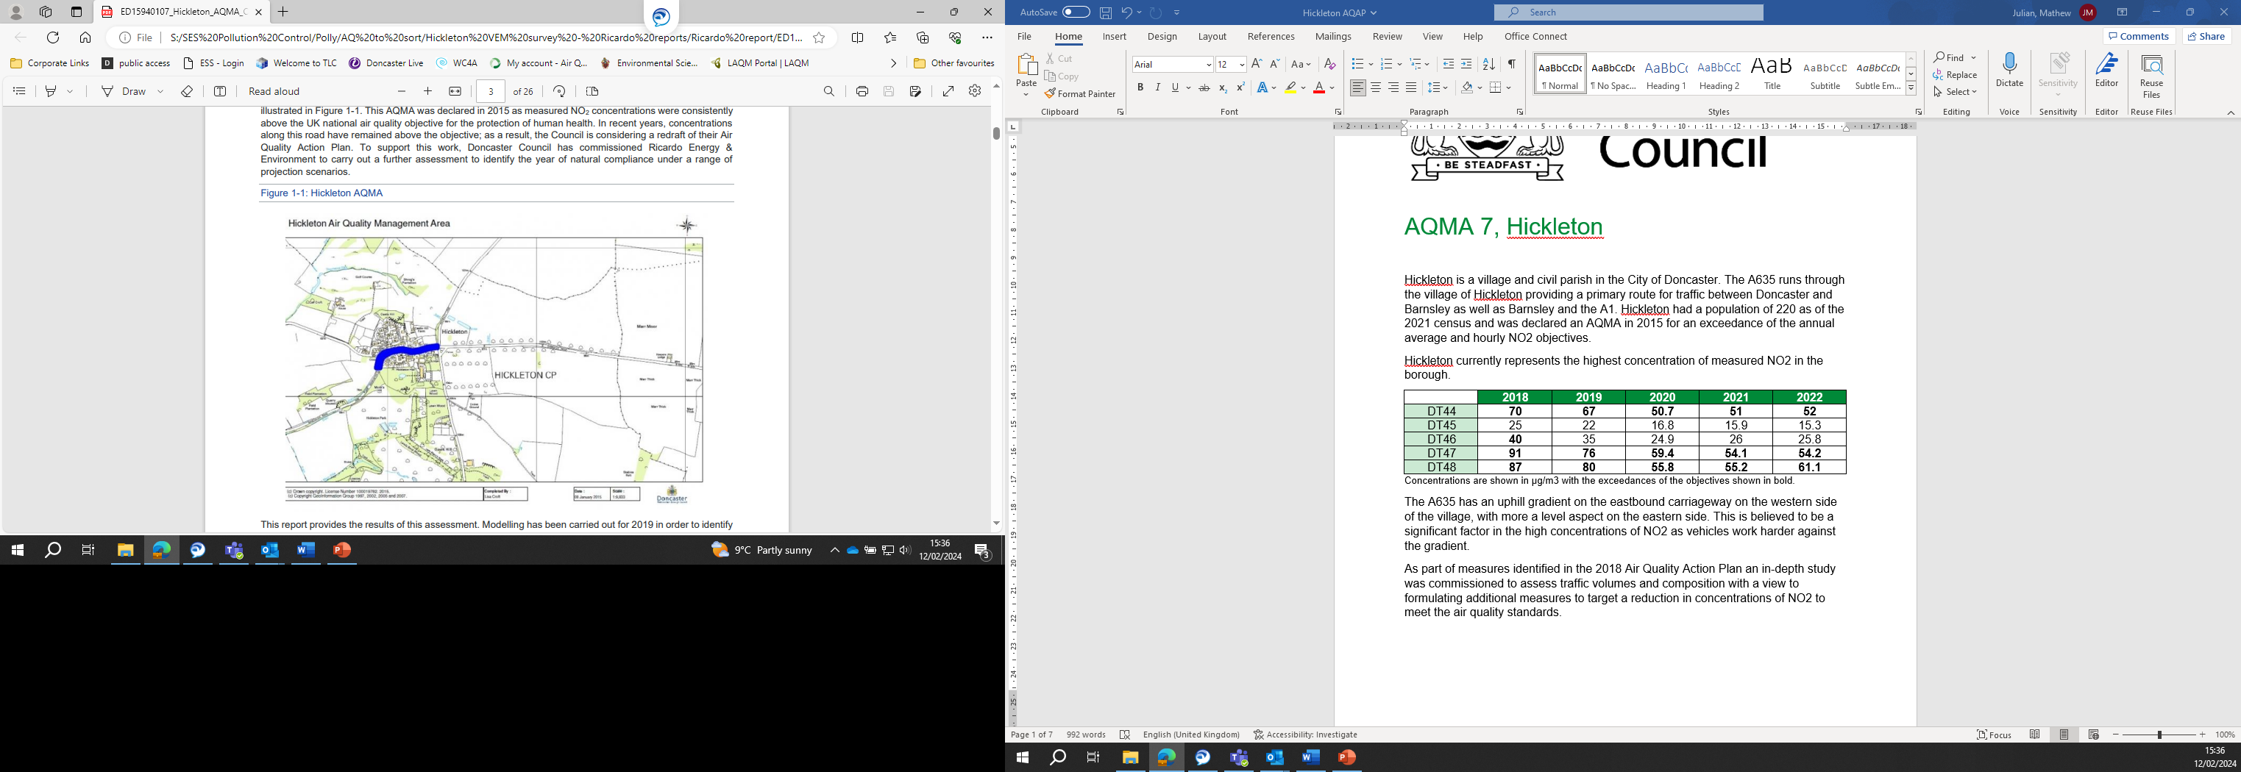
Hickleton currently represents the highest concentration of measured NO₂ in the borough.
Table 1 – Diffusion tube results in AQMA 7
 | 2018 | 2019 | 2020 | 2021 | 2022
DT44 | 70 | 67 | 50.7 | 51 | 52
DT45 | 25 | 22 | 16.8 | 15.9 | 15.3
DT46 | 40 | 35 | 24.9 | 26 | 25.8
DT47 | 91 | 76 | 59.4 | 54.1 | 54.2
DT48 | 87 | 80 | 55.8 | 55.2 | 61.1
Concentrations are shown in µg/m3 with the exceedances of the objectives shown in bold.
Table 2 – UK Nation Air Quality Objectives
Pollutant | Concentration | Measured as
Nitrogen Dioxide (NO₂) | 200 µg/m3 not to be exceeded more than 18 times a year: equivalent to a 99.8% percentile of hourly means not exceeding | 1hr mean
 | 40 µg/m3 | Annual mean
Particles (PM10) | 50 µg/m3 not to be exceeded more than 35 times a year | 24hr mean
 | 40 µg/m3 | Annual mean
Particles (PM2.5) | 25 µg/m3 | Annual mean

The A635 has an uphill gradient on the eastbound carriageway on the western side of the village, with more a level aspect on the eastern side. This is believed to be a significant factor in the high concentrations of NO₂ as vehicles work harder against the gradient.
As part of measures identified in the 2018 Air Quality Action Plan an in-depth study was commissioned to assess traffic volumes and composition with a view to formulating additional measures to target a reduction in concentrations of NO₂ to meet the air quality standards.
Vehicle Emission Report
Ricardo Energy and Environment have produced a Doncaster Council Real World Driving Emissions Study 2022 otherwise known as the Vehicle Emission report (available on the council’s webpage) which was completed in May 2022. This report presents an analysis of the real-world emissions made during measurement campaigns conducted in Hickleton. Vehicle emissions were measured using the Opus RSD5000 remote sensing instrument in conjunction with a camera which records number plates of passing vehicles and a pair of light gates to record the vehicle speed and acceleration. Over 26,000 vehicle measurements were made over the course of the measurement campaigns, including over 16,000 cars, 6,100 LGVs, 2,500 HGVs and 52 buses.
The benefits of real-world driving emissions data are:
- Remote sensing measurements are local to an area, therefore the emissions are representative of the actual vehicle fleet in the local area. Vehicle information such as vehicle type, age, mileage, makes and models are gained.
- Real-world emissions factors can be developed which will be representative of the driving conditions on the road.
- These real-world emissions factors can be used in local dispersion modelling and to inform predictions of air quality.
- Understanding local emissions sources can help LAs take targeted action to improve air quality, such as implementing Low Emission or Clean Air Zones (CAZ).
- With extended monitoring campaigns, remote sensing can go beyond current inventory approaches, for example looking at the impact of temperature and vehicle mileage on emissions.
Fleet Composition
The composition of the fleet surveyed during the Doncaster vehicle emissions remote sensing campaign is presented below.
Figure 1 – Fleet composition by measurement location and vehicle type.
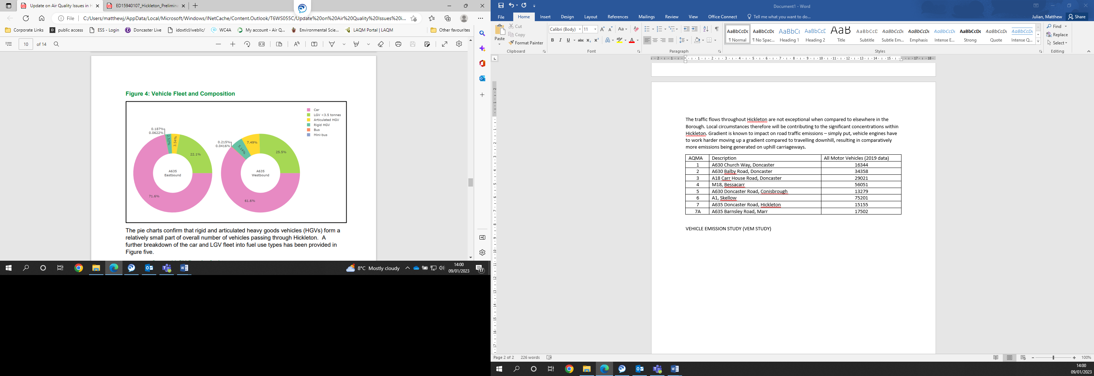
Figure 1 shows that cars make up the majority of vehicle movements through Hickleton. The breakdown of vehicles is similar between Eastbound and Westbound traffic. Overall, the fleet composition in Doncaster is similar to the NAEI fleet projections for 2022, where 78.0% of the vehicles in rural areas outside of London are cars, and 16.2% are LGVs.
Figure 2 - Cars by fuel type at the two measurement locations in the monitoring campaign.
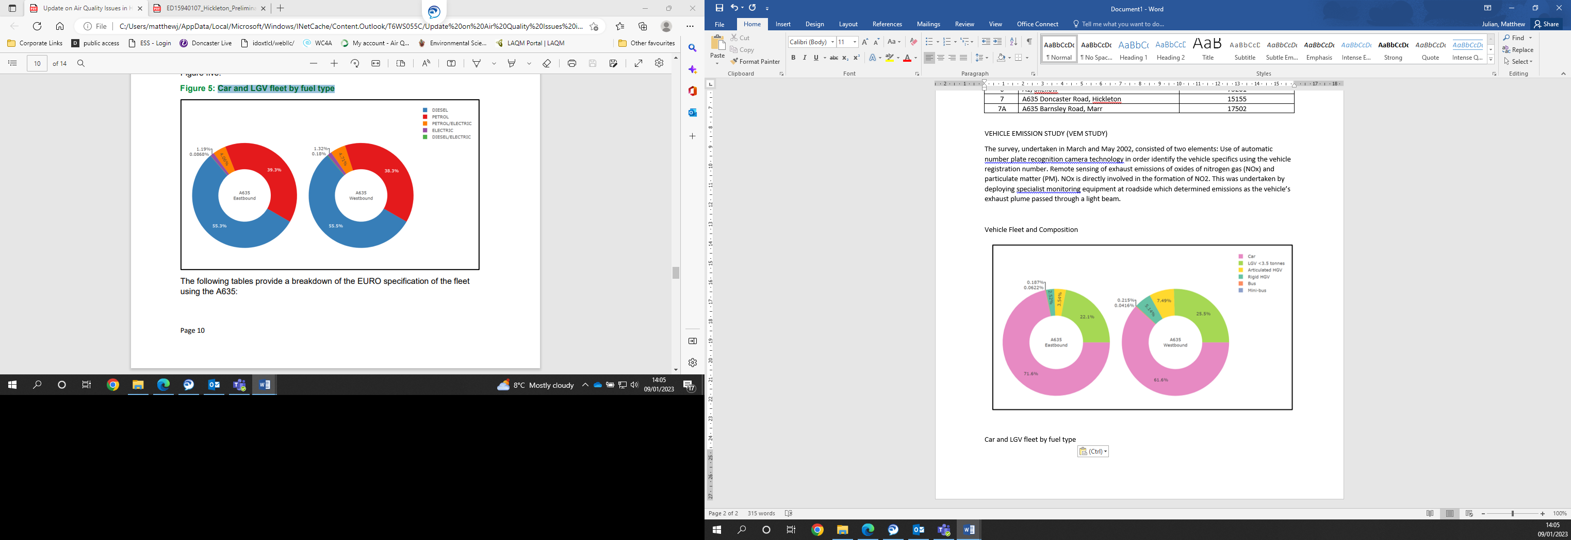
Figure 2 shows that 55% of cars captured by the study are fuelled by diesel. Vehicle emissions show a strong dependence on fuel type used by the vehicle. When assessing emissions, it is also important to consider the Euro standard classification of the vehicles and as such the vehicles were further analysed by euro standard classification in figures 3 and 4.
Figure 3 - Car and LGV fleet by fuel type and euro standard. 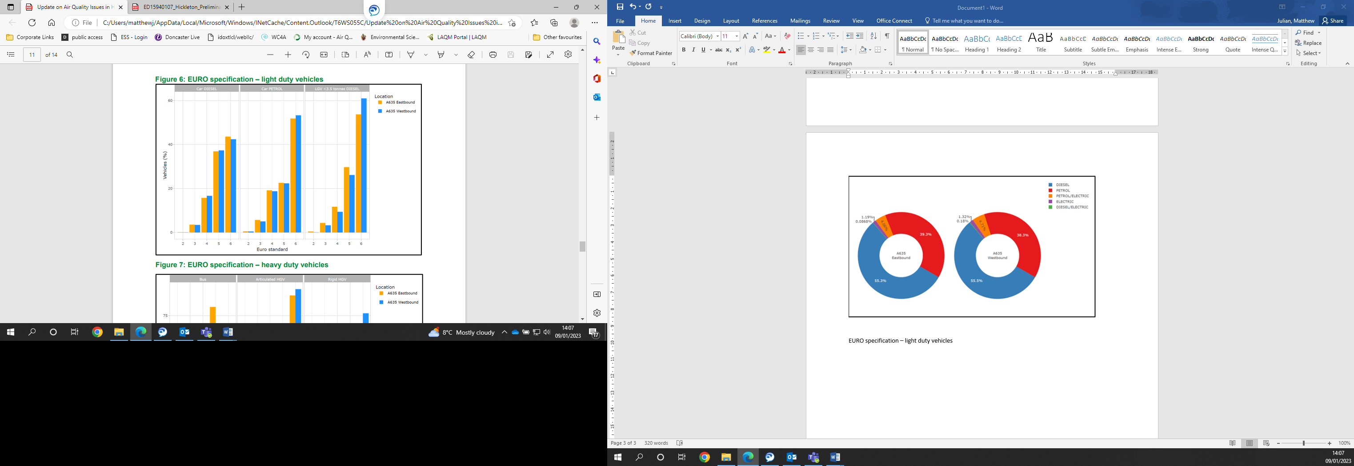
This figure shows that majority of vehicles in each type are Euro VI standard. This information is necessary when assessing the implementation and effectiveness of a CAZ as it shows which vehicles can access what class of CAZ and therefore the number of vehicles which can be excluded.

Figure 4 - Bus and HGV fleet by fuel type and euro standard.
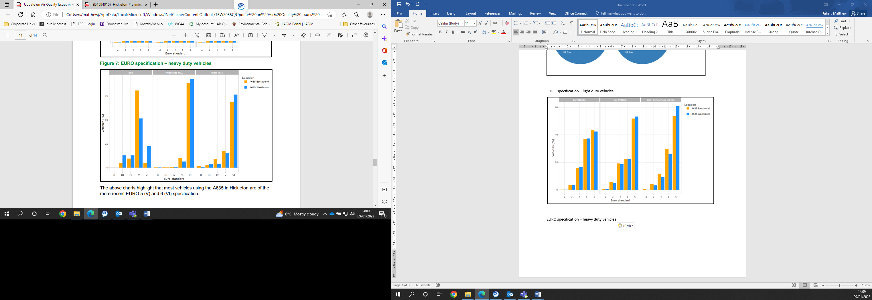
Figure 4 shows that the vast majority of HGV’s transiting through AQMA 7 are of a Euro 6 standard. This is attributed to the frequent use and high turnover of these vehicles. While it is encouraging that these vehicles are of a high Euro standard it does however mean that these vehicles would be difficult to target specifically as they would still be able to access even a class D CAZ.
Source apportionment
Source apportionment is the process of attributing the portion of the emissions to each source. This enables the identification of which vehicles are contributing the most to the emissions within the AQMA and therefore require assessing first.

Figure 5 - Eastbound
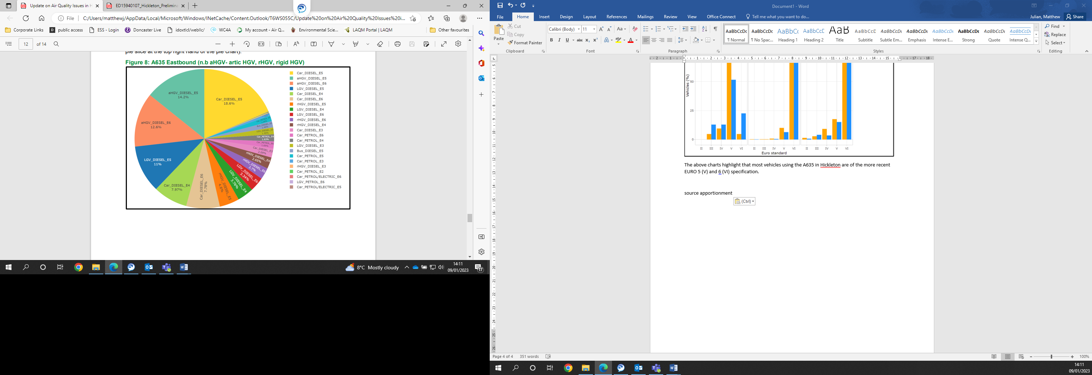
Figure 6 - Westbound
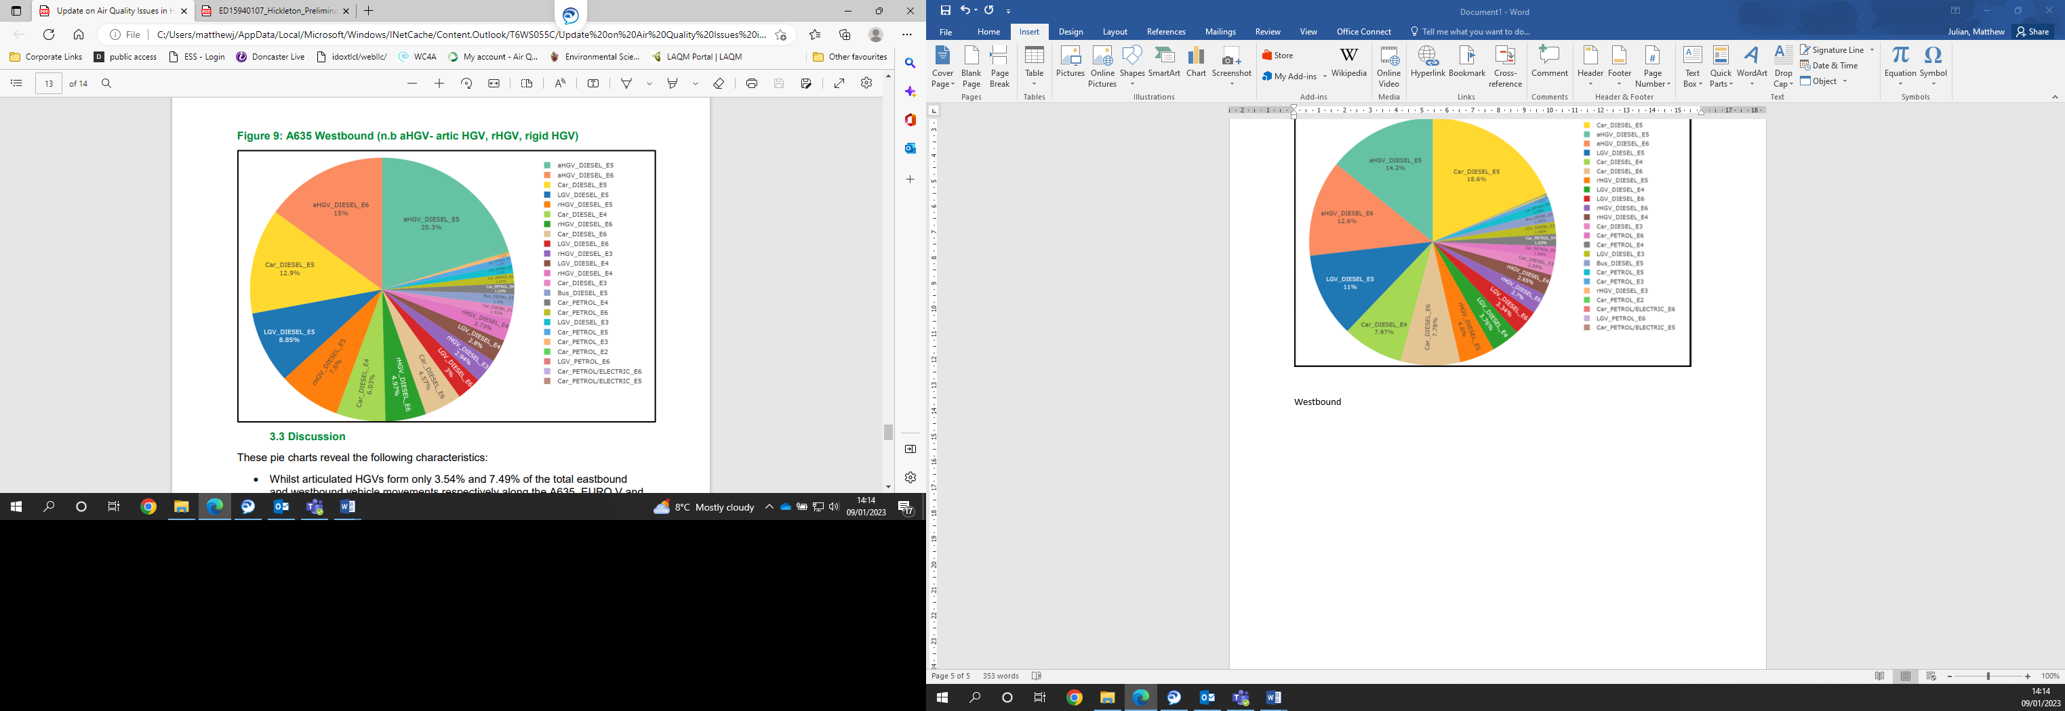
These charts for both eastbound and westbound show that the majority of emissions in AQMA 7 are attributed to diesel vehicles. While this is noteworthy, it is difficult at a local level to formulate measures to specifically target diesel fuelled vehicles.
Euro V diesel cars as well as Euro V and VI articulated HGVs are the top three emissions sources at both measurement locations.
Whilst articulated HGVs form only 3.54% and 7.49% of the total eastbound and westbound vehicle movements respectively along the A635, Euro V and VI arctic HGVs alone account for 26.8% and 35.5% of total NO_{x} emissions eastbound and westbound respectively.
Buses contribute only 1.46% eastbound and 1.5% westbound confirming that no specific measures are required for buses within AQMA 7.
To fully utilise this vehicle emission information in assessing future measures with a view to achieving compliance with air quality standards in AQMA 7, a further modelling report was commissioned. This modelling report would look at the concentrations of NO₂ at receptor locations, how emissions change in future years and how certain measures will affect future concentrations.
Hickleton AQMA Further Assessment
The Hickleton AQMA Further Assessment (also known as the modelling report) is a report produced by Ricardo Energy and Environment which uses the information collected in the Vehicle Emission report to further assess conditions in AQMA 7, this report was completed in March 23.
Modelling has been carried out for 2019 to identify areas of exceedance and validate the model. In order to identify the year of compliance, modelling has then been carried out for each year between 2022 and 2034, using national projections to predict future road transport emissions in Hickleton.
Sensitive Receptors
As part of the modelling exercise, it was necessary to identify the sensitive receptors which are being affected by the emissions from vehicles utilising the A635. Identifying receptors in this way allows for concentrations to be modelled for each individual location and a tailored solution sought. Below is a map showing the location of the receptor identified.

Figure 7 – Receptor locations in AQMA 7
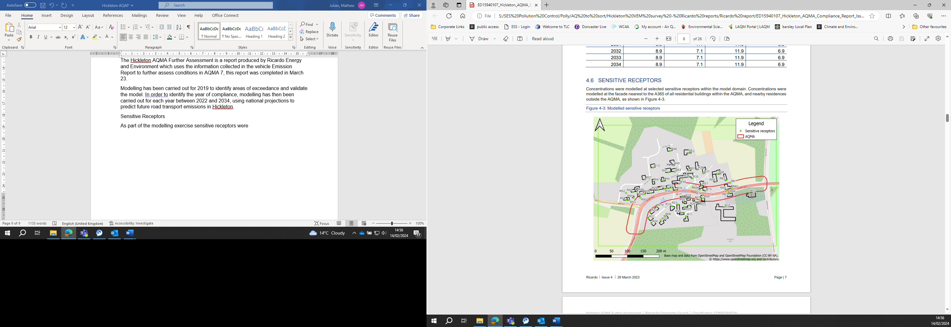
Baseline results
With the vehicle emission measured by the vehicle emission Report and the sensitive receptors identified, a model could be used to identify concentrations at sensitive receptor as of 2019 and predict future concentrations.
Particulate matter
The results of the modelling do not identify any exceedance of the Air Quality Objectives for particulate matter and therefore no measures will be considered for particulate matter at this time.
NO₂
The results of the modelling for 2019 have identified that 6 locations are in exceedance. As receptors R14 and R15 are modelled to be in compliance by 2023 they will no longer be considered to be in exceedance when considering future measures in AQMA 7. As such 4 receptor locations remain in exceedance of the objectives.

Figure 8 - NO₂ Concentrations at Receptor Locations
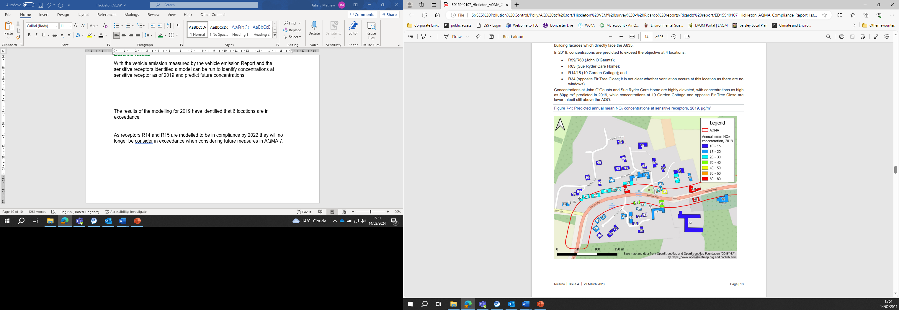
Predicted annual mean NO₂ concentrations at sensitive receptors µg/m3
The remaining four receptors identified which exceeded the national objective in 2019 are:
- R34.
- R59/60.
- R63,.
Table 3 presents predicted annual mean NO₂ concentrations at the sensitive receptors described in Section 2 for 2019, and each year between 2022 and 2035. Exceedances of the objective are highlighted in red.

Table 3 - Modelled NO₂ concentrations at receptor locations for future years
ID | 2019 | 2022 | 2023 | 2024 | 2025 | 2026 | 2027 | 2028 | 2029 | 2030 | 2031 | 2032 | 2033 | 2034
R01 | 14.4 | 12.5 | 11.9 | 11.3 | 10.8 | 10.4 | 10 | 9.7 | 9.4 | 9.2 | 9 | 9 | 8.9 | 8.6
R02 | 17.8 | 15.3 | 14.6 | 13.7 | 13.1 | 12.5 | 12 | 11.6 | 11.2 | 10.9 | 10.6 | 10.5 | 10.4 | 9.9
R03 | 17.9 | 15.4 | 14.6 | 13.8 | 13.1 | 12.6 | 12.1 | 11.6 | 11.3 | 11 | 10.7 | 10.6 | 10.5 | 9.9
R04 | 15 | 13 | 12.3 | 11.7 | 11.1 | 10.7 | 10.3 | 10 | 9.7 | 9.4 | 9.2 | 9.2 | 9.1 | 9.1
R05 | 16.8 | 14.5 | 13.8 | 13 | 12.3 | 11.8 | 11.4 | 11 | 10.7 | 10.4 | 10.2 | 10.1 | 10 | 9.5
R06 | 13.6 | 11.8 | 11.3 | 10.7 | 10.2 | 9.9 | 9.6 | 9.3 | 9 | 8.8 | 8.7 | 8.6 | 8.6 | 8.5
R07 | 13.5 | 11.8 | 11.2 | 10.6 | 10.2 | 9.8 | 9.5 | 9.2 | 9.0 | 8.7 | 8.6 | 8.5 | 8.5 | 8.1
R08 | 14.3 | 12.4 | 11.9 | 11.2 | 10.7 | 10.3 | 9.9 | 9.6 | 9.4 | 9.1 | 9 | 8.9 | 8.9 | 8.7
R09 | 16.5 | 14.3 | 13.5 | 12.8 | 12.1 | 11.7 | 11.2 | 10.8 | 10.5 | 10.2 | 10 | 9.9 | 9.8 | 9.5
R10 | 13.1 | 11.4 | 10.9 | 10.4 | 9.9 | 9.6 | 9.3 | 9 | 8.8 | 8.6 | 8.5 | 8.4 | 8.4 | 8.2
R11 | 12.6 | 11 | 10.5 | 10 | 9.6 | 9.3 | 9 | 8.7 | 8.5 | 8.3 | 8.2 | 8.2 | 8.2 | 8
R12 | 12.2 | 10.7 | 10.3 | 9.7 | 9.3 | 9.1 | 8.8 | 8.6 | 8.4 | 8..2 | 8.1 | 8 | 8 | 7.8
R13 | 12.7 | 11.1 | 10.6 | 10 | 9.6 | 9.3 | 9 | 8.8 | 8.6 | 8.4 | 8.3 | 8.2 | 8.2 | 7.9
R14 | 48.6 | 41.3 | 38.7 | 36.2 | 34 | 32 | 30.2 | 28.6 | 27.4 | 26.4 | 24.9 | 24.3 | 23.8 | 22.3
R15 | 48.6 | 41.4 | 38.6 | 35.9 | 33.6 | 31.6 | 29.7 | 28.1 | 26.9 | 25.9 | 24.4 | 23.8 | 23.3 | 21.6
R16 | 20.6 | 17.8 | 16.8 | 15.8 | 15 | 14.3 | 13.7 | 13.2 | 12.8 | 12.4 | 12 | 11.9 | 11.8 | 11
R17 | 22.1 | 19.1 | 18 | 16.9 | 16 | 15.3 | 14.6 | 14 | 13.6 | 13.2 | 12.7 | 12.6 | 12.4 | 11.6
R18 | 15.1 | 13.1 | 12.4 | 11.7 | 11.2 | 10.7 | 10.4 | 10 | 9.7 | 9.5 | 9.3 | 9.2 | 9.2 | 8.9
R19 | 17.5 | 15 | 14.2 | 13.4 | 12.7 | 12.2 | 11.7 | 11.2 | 10.9 | 10.6 | 10.3 | 10.2 | 10.1 | 9.9
R20 | 13.5 | 11.8 | 11.3 | 10.7 | 10.2 | 9.8 | 9.5 | 9.2 | 9 | 8.8 | 8.6 | 8.6 | 8.5 | 8.5
R21 | 17.2 | 14.8 | 14 | 13.2 | 12.6 | 12 | 11.5 | 11.1 | 10.8 | 10.5 | 10.2 | 10.1 | 10 | 9.9
R22 | 18.5 | 15.9 | 15 | 14.1 | 13.3 | 12.7 | 12.2 | 11.7 | 11.3 | 11 | 10.7 | 10.6 | 10.4 | 10.2
R23 | 15.3 | 13.2 | 12.6 | 11.9 | 11.3 | 10.9 | 10.5 | 10.2 | 9.9 | 9.6 | 9.4 | 9.3 | 9.3 | 9
R24 | 13.1 | 11.4 | 11 | 10.4 | 9.9 | 9.6 | 9.3 | 9 | 8.8 | 86 | 8.5 | 8.4 | 8.4 | 8.2
R25 | 14.3 | 12.4 | 11.8 | 11.2 | 10.7 | 10.3 | 9.9 | 9.6 | 9.4 | 9.1 | 9 | 8.9 | 8.9 | 8.6
R26 | 14.6 | 12.7 | 12.1 | 11.5 | 10.9 | 10.5 | 10.2 | 9.8 | 9.6 | 9.3 | 9.2 | 9.1 | 9 | 8.7
R27 | 15.4 | 13.4 | 12.7 | 12 | 11.4 | 11 | 10.6 | 10.3 | 10 | 9.7 | 9.5 | 9.4 | 9.4 | 9
R28 | 20.2 | 17.3 | 16.3 | 15.3 | 14.4 | 13.7 | 13.1 | 12.6 | 12.1 | 11.8 | 11.4 | 11.2 | 11.1 | 10.7
R29 | 20.2 | 17.3 | 16.3 | 15.3 | 14.4 | 13.7 | 13.1 | 12.6 | 12.1 | 11.8 | 11.4 | 11.2 | 11.1 | 10.7
R30 | 28.6 | 24.4 | 22.7 | 21.2 | 19.9 | 18.8 | 17.8 | 16.9 | 16.3 | 15.7 | 15 | 14.7 | 14.5 | 13.6
R31 | 28.7 | 24.5 | 22.8 | 21.3 | 20 | 18.9 | 17.9 | 17 | 16.4 | 15.8 | 15.1 | 14.8 | 14.6 | 13.7
R32 | 29.4 | 25.2 | 23.4 | 21.8 | 20.5 | 19.3 | 18.3 | 17.5 | 16.8 | 16.2 | 15.5 | 15.2 | 14.9 | 14
R33 | 29 | 24.9 | 23.2 | 21.6 | 20.3 | 19.2 | 18.2 | 17.3 | 16.7 | 16.1 | 15.4 | 15.1 | 14.9 | 13.9
R34 | 72.9 | 62.4 | 58.6 | 54.6 | 51.2 | 48 | 45.2 | 42.8 | 40.9 | 39.3 | 36.9 | 35.9 | 35.1 | 31.9
R35 | 17.1 | 14.8 | 14 | 13.2 | 12.5 | 12 | 11.5 | 11.1 | 10.8 | 10.5 | 10.2 | 10.1 | 10 | 9.8
R36 | 14 | 12.2 | 11.6 | 11 | 10.5 | 10.1 | 9.8 | 9.5 | 9.2 | 9 | 8.9 | 8.8 | 8.7 | 8.6
R37 | 14.5 | 12.6 | 12 | 11.3 | 10.8 | 10.4 | 10 | 9.7 | 9.4 | 9.2 | 9 | 9 | 8.9 | 8.8
R38 | 16.8 | 14.6 | 13.8 | 13 | 12.4 | 11.9 | 11.4 | 11 | 10.7 | 10.4 | 10.1 | 10 | 10 | 9.5
R39 | 20.5 | 17.7 | 16.7 | 15.6 | 14.8 | 14.1 | 13.5 | 13 | 12.6 | 12.2 | 11.8 | 11.7 | 11.5 | 10.9
R40 | 15.5 | 13.4 | 12.7 | 12 | 11.4 | 10.9 | 10.5 | 10.2 | 9.9 | 9.6 | 9.4 | 9.4 | 9.3 | 8.9
R41 | 14.1 | 12.3 | 11.7 | 11.1 | 10.6 | 10.2 | 9.8 | 9.5 | 9.3 | 9.1 | 8.9 | 8.8 | 8.8 | 8.4
R43 | 14.4 | 12.5 | 11.9 | 11.3 | 10.8 | 10.4 | 10 | 9.7 | 9.4 | 9.2 | 9 | 9 | 8.9 | 8.5
R45 | 13.2 | 11.5 | 11 | 10.5 | 10 | 9.7 | 9.4 | 9.1 | 8.8 | 8.6 | 8.5 | 8.5 | 8.4 | 8.1
R46 | 11.9 | 10.4 | 10 | 9.5 | 9.1 | 8.9 | 8.6 | 8.4 | 8.2 | 8 | 7.9 | 7.9 | 7.9 | 7.6
R47 | 14.6 | 12.7 | 12.1 | 11.4 | 10.9 | 10.4 | 10.1 | 9.8 | 9.5 | 9.2 | 9.1 | 9 | 8.9 | 8.5
R48 | 14.8 | 12.8 | 12.2 | 11.5 | 11 | 10.6 | 10.2 | 9.8 | 9.6 | 9.3 | 9.1 | 9.4 | 9 | 8.5
R49 | 23.6 | 20.1 | 18.9 | 17.6 | 16.6 | 15.7 | 15 | 14.3 | 13.8 | 13.3 | 12.8 | 12.6 | 12.4 | 11.4
R50 | 22.5 | 19.2 | 18 | 16.8 | 15.8 | 14.9 | 14.2 | 13.6 | 13.1 | 12.6 | 12.1 | 11.9 | 11.8 | 10.8
R51 | 14.2 | 12.3 | 11.8 | 11.1 | 10.6 | 10.2 | 9.9 | 9.6 | 9.3 | 9.1 | 8.9 | 8.8 | 8.8 | 8.3
R52 | 13.4 | 11.7 | 11.2 | 10.6 | 10.1 | 9.8 | 9.5 | 9.2 | 8.9 | 8.7 | 8.6 | 8.5 | 8.5 | 8.1
R53 | 16.4 | 14.2 | 13.5 | 12.7 | 12.1 | 11.6 | 11.1 | 10.7 | 10.4 | 10.1 | 9.9 | 9.8 | 9.7 | 9.2
R54 | 15.4 | 13.4 | 12.8 | 12.1 | 11.5 | 11 | 10.6 | 10.3 | 10 | 9.7 | 9.5 | 9.4 | 9.3 | 8.9
R55 | 16.2 | 14 | 13.3 | 12.5 | 11.9 | 11.4 | 11 | 10.6 | 10.3 | 10 | 9.7 | 9.6 | 9.6 | 9
R56 | 27.2 | 23.4 | 21.9 | 20.4 | 19.3 | 18.2 | 17.3 | 16.6 | 16 | 15.4 | 14.8 | 14.5 | 14.3 | 14.2
R57 | 19 | 16.4 | 15.5 | 14.5 | 13.8 | 13.1 | 12.6 | 12..1 | 11.7 | 11.4 | 11.1 | 10.9 | 10.8 | 10.8
R58 | 15.9 | 13.7 | 13 | 12.3 | 11.7 | 11.2 | 10.8 | 10.4 | 10.1 | 9.8 | 9.6 | 95 | 9.5 | 9.3
R59 | 75.9 | 63.7 | 60.7 | 57.2 | 54.1 | 51.1 | 48.4 | 45.9 | 44.1 | 42.4 | 40 | 38.9 | 38.1 | 37.3
R60 | 75.1 | 63.2 | 60.3 | 56.9 | 53.8 | 50.8 | 48.1 | 45.7 | 43.8 | 42.2 | 39.7 | 38.7 | 37.9 | 37
R61 | 17.1 | 14.7 | 14 | 13.2 | 12.5 | 12 | 11.5 | 11.1 | 10.8 | 10.5 | 10.2 | 10.1 | 10 | 9.9
R62 | 15.9 | 13.8 | 13.1 | 12.3 | 11.7 | 11.3 | 10.9 | 10.5 | 10.2 | 9.9 | 9.7 | 9.6 | 9.5 | 9.4
R63 | 68.5 | 57.8 | 54.6 | 51.2 | 48.2 | 45.3 | 42.7 | 40.5 | 38.7 | 37.2 | 34.9 | 34 | 33.2 | 32.2
R64 | 16.5 | 14.3 | 13.5 | 12.8 | 12.1 | 11.6 | 11.2 | 10.8 | 10.5 | 10.2 | 9.9 | 9.8 | 9.8 | 9.7
Exceedance of the NO₂ annual average objective is shown in red.
At R59/60, annual mean NO₂ concentrations are predicted to fall just below the UK Air Quality Objective of 40 µg/m³ in 2032 without further action. However, these predictions are subject to a large degree of uncertainty, particularly with respect to fleet projections and future emissions standards, and therefore these results do not indicate that compliance will definitely be achieved within this timeframe.
At R63 and R34, concentrations are predicted to fall below the objective in 2029 and 2030, respectively.
To achieve compliance with the air quality objectives at the identified receptors as soon as possible will require substantial measures to tackle NO₂ concentrations.
Modelled Source Apportionment
The fleet passing through Hickleton will change over the coming years due to the increased uptake of electric vehicles. Figure shows the percentage contribution of different vehicle types to NO_{x} (NO plus NO₂) concentrations at R59/R60 in 2019 and 2030. In both years, diesel cars are the largest contributor to NO_{x} concentrations, contributing 35% of the total local NO_{x} in 2019 and 49% in 2019. This is typical of roadside sites across the UK, as diesel vehicles have greater NO_{x} emissions than petrol vehicles.
LGVs and HGVs also contribute substantially to NO_{x} concentrations at the site, as these diesel vehicles emit high levels of NO_{x} per vehicle.
The contribution of diesel cars relative to other vehicles is predicted to increase over time. This indicates that a greater than anticipated shift from diesel to electric cars could reduce concentrations further than is predicted in this baseline model.
Figure 9 - Future Source Apportionment at R59/60
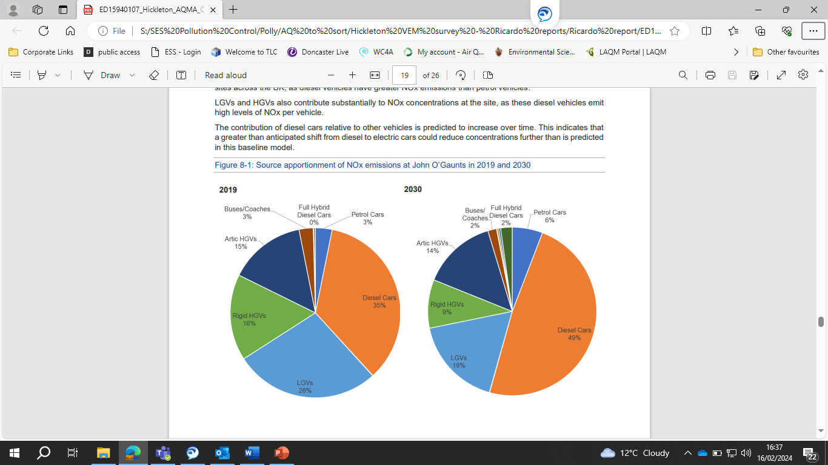
Modelled Measures
AQMA 7 is not predicted to achieve compliance until 2032 and so, to achieve compliance sooner new air quality measures will be required.
Using the data gathered from the Real World Driving Emissions Study (Vehicle Emission study) and the Hickleton AQMA Further Assessment (Modelling report) it is possible to model the impacts of certain scenarios to assess their outcome and suitability in addressing the high concentrations of NO₂.
Scenario 1 – Fleet Delay
Scenario 1 is an outcome that could arise if the rate at which individuals replace their cars is lower than national predictions suggest, this can occur for example in adverse economic circumstances.
Modelling has been carried out to predict a delay in fleet turnover of 2 years and the table below shows the impact this will have on emissions.
Table 4 – Impacts of Scenario 1.
Year | R14 | R34 | R60 | R63
2022 | 8 | 12.2 | 11.1 | 10.7
2024 | 5.1 | 8 | 6.6 | 6.7
2026 | 3.9 | 6.8 | 6.3 | 6
2028 | 3 | 5.4 | 5.3 | 4.9
2030 | 1.7 | 3.6 | 3.7 | 3.4
2032 | 2.3 | 3.7 | 3.9 | 3.5
2034 | 0.7 | 1.1 | 1.1 | 2.1
Increases in NO₂ concentration are shown in red with decreases in green.
Difference in µg/m³ compared to predicted year concentration without scenario occurring.
As can be seen, the Fleet Delay scenario will lead to higher concentrations in all modelled years.
Unfortunately, there are no significant measures which can be implemented at a local level to increase the turnover of the fleet or prevent a delay in predicted turnover. Scrappage schemes and subsidies for new vehicles at central government level would be beneficial in maintaining the rate of refresh.
Scenario 2 – 20 mph speed limit in AQMA
This scenario models the concentrations if the traffic speeds on roads within Hickleton where the modelled speed is greater than 20 mph in the baseline model were reduced to 20 mph, thereby increasing average emission rates along these roads.

Table 5 – Impacts of Scenario 2.
Year | R14 | R34 | R60 | R63
2022 | 1.1 | 0.2 | 1.9 | 1.7
2024 | 0.7 | 0.2 | 1.9 | 1.6
2026 | 0.3 | -0.1 | 1.4 | 1.2
2028 | 0.2 | -0.1 | 1.3 | 1.1
2030 | 0.1 | -0.1 | 1.3 | 1
2032 | 0.4 | 0 | 1.2 | 1
2034 | 0.6 | -0.1 | 1 | 1.9
Increases in NO₂ concentration are shown in red with decreases in green.
Difference in µg/m³ compared to predicted year concentration without scenario occurring.
While reducing concentrations at receptor location R34 this measure would lead to increased concentrations at the other three locations which are in exceedance meaning that this is not a measure to be taken forward.
Scenario 3 – ES10 Development
This scenario models the predicted concentrations from emissions that will be added to the receptor locations if the proposed development in Goldthorpe referred to as ES10 is constructed. It is anticipated that traffic from this development will transit through AQMA 7 to access the A1 and therefore increase emissions through Hickleton.
Traffic flows for this scenario were derived from the transport assessment carried out for this development.
Table 6 – Impact of Scenario 3.
Year | R14 | R34 | R60 | R63
2022 | 0.8 | 1 | 1.1 | 1.1
2024 | 0.4 | 1 | 1.1 | 1
2026 | 0.1 | 0.6 | 0.6 | 0.7
2028 | 0.1 | 0.8 | 1 | 0.8
2030 | 0 | 0.7 | 0.9 | 0.8
2032 | 0.4 | 0.7 | 0.7 | 0.7
2034 | 0.4 | 0.6 | 0.6 | 1.6
Increases in NO₂ concentration are shown in red with decreases in green.
Difference in µg/m3 compared to predicted year concentration without scenario occurring.
The modelled results show that this development will increase concentrations at all receptor locations. As such CDC will work with Barnsley Council to seek to mitigate the impact of this development.
Scenario 4 – Class D Clean Air Zone (CAZ)
This scenario models the reductions in emissions that can be expected if a Class D CAZ were to be implemented through AQMA 7. A Class D CAZ would seek to include the following vehicle types:
Buses, coaches, taxis, private hire vehicles, heavy goods vehicles, vans, minibuses, cars, the local authority has the option to include motorcycles.
The minimum emission standards a vehicle would need to meet to be exempt would be:
Buses, coaches, heavy goods vehicles Euro VI
Vans, minibuses, taxis, private hire vehicles, cars Euro VI (diesel) and Euro IV (petrol)
Motorcycles Euro III
Table 7 – Impact of Scenario 4
Year | R14 | R34 | R60 | R63
2022 | -4.7 | -7.9 | -4.8 | -5.3
2024 | -3.2 | -4.9 | -3.4 | -3.6
2026 | -2.2 | -3 | -2.3 | -2.3
2028 | -1.5 | -1.8 | -1.4 | -1.4
2030 | -1.1 | -1 | -0.8 | -0.8
2032 | -0.2 | -0.4 | -0.3 | -0.3
2034 | -0.2 | -0.3 | -0.4 | 0.7
Increases in NO₂ concentration are shown in red with decreases in green.
Difference in µg/m3 compared to predicted year concentration without scenario occurring.
The modelled results show that implementing a Class D would achieve a reduction in NO₂ concentrations at each receptor.
As only the CAZ would reduce concentrations of NO₂ this is the only scenario worth further consideration. For the purposes of achieving compliance with the Air Quality Objectives it is necessary to assess the impacts of the potential reduce concentrations of NO₂ with regards to compliance.
Table 8 shows the concentration of NO₂ at each receptor location if the Class D CAZ were to be implemented. Exceedances of the objective are shown in red.
Table 8 – NO2 concentrations in event of Class D CAZ implementation.
Year | R14 | R34 | R60 | R63
2022 | 36.6 | 54.5 | 58.9 | 52.5
2024 | 33 | 49.7 | 53.8 | 47.6
2026 | 29.8 | 45 | 48.8 | 43.0
2028 | 27.1 | 41 | 44.5 | 39.1
2030 | 25.3 | 38.3 | 41.6 | 36.4
2032 | 23.6 | 35.5 | 38.6 | 33.7
2034 | 23.1 | 34.8 | 37.7 | 32.9

As can been seen in the above table the Class D CAZ would achieve compliance in AQMA 7 at a point between 2030 and 2032.
As the modelling without a Class D CAZ predicts compliance by 2032 the implementation of a CAZ does not significantly bring forward compliance with the objectives.
During assessment of a potential CAZ, CDC steering group have also considered the economic impact, public opinion, and the potential for traffic to reroute to avoid the CAZ thereby creating increased traffic and emissions on other roads in the vicinity. It is therefore considered that a Class D CAZ would not have enough of an impact on achieving compliance to warrant further investigation.
Specific Measures for AQMA 7 to be included in AQAP
The exceedances affecting AQMA 7 are substantial and as such require a significant intervention to achieve compliance.
The Ricardo Vehicle Emission report and Modelling reports have been valuable in helping CDC both understand the situation in AQMA 7 and identify what measures may or may not achieve the required reductions to bring the AQMA into compliance.
Having discounted the prospect of a Class D CAZ it is now important to explore other potential measures which could be implemented to achieve the required reduction in NO₂ emissions.
Roadvent
Roadvent is an innovative technology to significantly improve air quality. By pulling in dirty air into the Roadvent slots within the road and cleaning it at the roadside through the use of filters, the ground-breaking technology has an instant, positive impact on air quality once installed.
Roadvent is installed in sections and therefore can be used to target specific parts of road nearest to the receptors in exceedance.
As this technology is new to the market there is currently no systems installed in a road with running traffic. As such durability and effectiveness are yet to be proved in circumstances similar to AQMA 7.
CDC will continue to keep abreast of developments with this promising technology and will actively work towards assessing the feasibility of installing this measure within AQMA 7. As such this will be included as a measure in the new Air Quality Action Plan.
Removing Receptors
A potential measure to reduce exposure to concentrations of NO₂ which exceed the Air Quality standards is to remove the receptors from the area currently in exceedance.
This measure would involve approaching the residents of the properties which have been identified to be in exceedance of the objectives and offering to purchase the properties to enable the residents to move to an area with lower concentrations of NO₂.
This measure should enable CDC to revoke the AQMA subject to further monitoring to ensure no addition traffic or other sources significantly affect the modelled concentrations at other receptor locations.
While this measure is promising there remains multiple issues. Significant funds would be required to enact this measure, and this would be reliant on the willingness of residents to accept this measure. Further consideration would be required as to how best to use or maintain the purchased property once obtained.
As this measure presents an avenue to achieving the objectives in an area of high exceedance it is worthy of further investigation despite potential concerns.
Hickleton/Marr Bypass
A Hickleton/Marr Bypass is a measure to construct a road bypassing AQMA 7 and thereby create an alternative route for the traffic. This measure will significantly reduce emissions from traffic in Hickleton hopefully achieving compliance with the objectives and allowing CDC to revoke the AQMA.
The Hickleton/Marr Bypass has been investigated previously; however, the scheme was considered to not meet the required value for money and was also dependent on complementary investment such as Dearne Valley Parkway, which is no longer progressing following government decisions around rail infrastructure.
Since this assessment the Hickleton/Marr Bypass has been included within Network North which is a new £36 billion plan to improve the country’s transport. This means that the Hickleton/Marr Bypass is again being assessed for viability and may form a potential measure that could be brought forward subject to various assessments and approvals.
As a major project this measure is complex and will be beyond the full control of CDC. As such, while this is a promising measure, which is expected to achieve compliance with the objectives, this measure has not been confirmed and no timeframes are available.
Conclusion
In response to the significant exceedance of the NO₂ annual average objective in AQMA 7, the Ricardo Energy and Environment reports have been useful in selecting specific measures which are to be progressed in the new AQAP.
In formulating these specific measures to be added to the AQAP, CDC have been able to assess the traffic transiting through AQMA 7 and the associated emissions from each vehicle classification. While CDC have not been able to include specific measure to target the highest polluting vehicles (such as diesel cars or HGV’s) it has been able to discount measures which will not provide the impact required (CAZ).
The specific measures selected are designed to achieve compliance within AQMA 7 despite the significant exceedance currently being experienced. These measures will require further investigation into viability to identify which measure if any are suitable for implementation.

Glossary of Terms
Abbreviation | Description
AQAP | Air Quality Action Plan - A detailed description of measures, outcomes, achievement dates and implementation methods, showing how the local authority intends to achieve air quality limit values’
AQMA | Air Quality Management Area – An area where air pollutant concentrations exceed / are likely to exceed the relevant air quality objectives. AQMAs are declared for specific pollutants and objectives
AQS | Air Quality Strategy
ASR | Air quality Annual Status Report
CDC | City of Doncaster Council
Defra | Department for Environment, Food and Rural Affairs
EU | European Union
LAQM | Local Air Quality Management
NO₂ | Nitrogen Dioxide
NO_{x} | Nitrogen Oxides
PM₁₀ | Airborne particulate matter with an aerodynamic diameter of 10µm (micrometres or microns) or less
PM_{2.5} | Airborne particulate matter with an aerodynamic diameter of 2.5µm or less
CO | Carbon Monoxide
NH₃ | Ammonia
SO₂ | Sulphur Dioxide
NMVOC’s | Non-Methane Volatile Organic Compounds
SYMCA | South Yorkshire Mayoral Combined Authority

References
Wheeler, B and Ben-Shlomo, Y, Environmental equity, air quality, socioeconomic status and respiratory health (2010) https://jech.bmj.com/content/jech/59/11/948.full.pdf

Department for Environment, Food & Rural Affairs, Air quality and social deprivation in the UK: an environmental inequalities analysis (2006) https://uk-air.defra.gov.uk/assets/documents/reports/cat09/0701110944_AQinequalitiesFNL_AEAT_0506.pdf

Department for Environment, Food & Rural Affairs, Abatement cost guidance for valuing changes in air quality (May 2013) https://assets.publishing.service.gov.uk/government/uploads/system/uploads/attachment_data/file/197898/pb13912-airquality-abatement-cost-guide.pdf

Guidance Air pollution: applying All Our Health Updated 28 February 2022 https://www.gov.uk/government/publications/air-pollution-applying-all-our-health/air-pollution-applying-all-our-health

Estimating local mortality burdens associated with particulate air pollution Estimating local mortality burdens associated with particulate air pollution - GOV.UK (www.gov.uk)

Doncaster Councils Air Quality Action Plan and Annual Reports, Doncaster Council http://www.doncaster.gov.uk/services/environmental/air-quality-reports-available-to-the-public

City of Doncaster Council Local Plan https://www.doncaster.gov.uk/services/planning/local-plan

City of Doncaster Council Technical & Developer Requirements Supplementary Planning Document https://www.doncaster.gov.uk/services/planning/ldf-supplementary-planning-documents

City of Doncaster Council Environment and Sustainability Strategy 2020-2030
https://doncaster.moderngov.co.uk/documents/s28624/Environment%20Strategy%20AppendixA.pdf

UK Regions (exc. London) Technical Guidance (TG22) https://laqm.defra.gov.uk/air-quality/featured/uk-regions-exc-london-technical-guidance/

England (exc. London) Policy Guidance (PG22) https://laqm.defra.gov.uk/air-quality/featured/england-exc-london-policy-guidance/

Doncaster Council, Doncaster Cycling Strategy (2013) http://www.doncaster.gov.uk/services/transport-streets-parking/cycling

Doncaster hydrogen refuelling hub https://www.betatechnology.co.uk/doncaster-hydrogen-hub

Environmental equity, air quality, socioeconomic status and respiratory health, 2010
Air quality and social deprivation in the UK: an environmental inequalities analysis, 2006
Defra. Abatement cost guidance for valuing changes in air quality, May 2013
Guidance Air pollution: applying All Our Health Updated 28 February 2022 Air pollution: applying All Our Health - GOV.UK (www.gov.uk)
Estimating Local Mortality Burdens associated with Particulate Air Pollution, Public Health England, 2014

